RIPHAH CAPSTONE


By:
Ayesha Butt
48288
Iman Arshad
46188
Sana Arshad
46189

Supervised by:
Dr Hajra Murtaza
Faculty of Computing
Riphah International University, Islamabad
Fall 2025
A Dissertation Submitted To

Faculty of Computing,
Riphah International University, Islamabad
As a Partial Fulfillment of the Requirement for the Award of
the Degree of
Bachelors of Science in Software Engineering

Faculty of Computing
Riphah International University, Islamabad
Date: 11-november-2025
Final Approval

This is to certify that we have read the report submitted by Ayesha Butt (48288), Iman Arshad (46188), and Sana Arshad (46189) for the partial fulfillment of the requirements for the degree of the Bachelors of Science in Software Engineering (BSSE). It is our judgment that this report is of sufficient standard to warrant its acceptance by Riphah International University, Islamabad for the degree of Bachelors of Science in Software Engineering (BSSE).

Committee:

1 | Dr Hajra Murtaza  (Supervisor)
2 | Dr Tahira nazir  (Head of Department/chairman)

Declaration

We hereby declare that this document “Riphah Capstone” neither as a whole nor as a part has been copied out from any source. It is further declared that we have done this project with the accompanied report entirely on the basis of our personal efforts, under the proficient guidance of our teachers especially our supervisor Dr Hajra Murtaza. If any part of the system is proved to be copied out from any source or found to be reproduction of any project from anywhere else, we shall stand by the consequences.

___________________________
Ayesha Butt
48288

___________________________
Iman Arshad
46188

___________________________
Sana Arshad
46189

Dedication
The successful completion of this project, “Riphah capstone”, is devoted to our parents for their unwavering support, which has been our source of strength, and to our supervisor and faculty members for their invaluable guidance and encouragement throughout this endeavor.

Acknowledgement

First of all we are obliged to Allah Almighty the Merciful, the Beneficent and the source of all Knowledge, for granting us the courage and knowledge to complete this Project.
We also wish to express our gratitude to our supervisor for his guidance during this project; and to all teachers, classmates, friends and family who supported us throughout this adventure

___________________________
Ayesha Butt
48288

___________________________
Iman Arshad
46188

___________________________
Sana Arshad
46189

Abstract

The FYP is a crucial component of every degree program; however, at our university, the management of this process is still conducted manually. This manual system presents numerous challenges, such as frequent miscommunication, delays in receiving feedback, uneven distribution of workloads among supervisors, ineffective tracking of deadlines, and a decline in academic quality. These issues not only impact student performance but also impose an unnecessary burden on faculty. To tackle these challenges, we have created “Riphah Capstone” fully automated management system for final year projects (FYP). This system consolidates all aspects of the FYP process into one platform, facilitating effective collaboration among students, supervisors, project coordinators, and administrators. It features automated submission and approval of proposals, equitable allocation of supervisors, tracking of milestones and tasks, feedback systems, scheduling of deadlines and meetings, and clear evaluation processes. Additionally, notifications enhance coordination, while structured checklists help students stay aligned with academic criteria. This project illustrates that automating the FYP process can significantly enhance efficiency and academic quality. By reducing delays, minimizing errors, and ensuring accountability, Riphah Capstone offers a dependable and scalable solution that can modernize FYP management and act as a viable model for our university.

Table of Contents
List of Tables 12
Chapter 1: 13
Introduction 13
1.2 Opportunity & Stakeholders 14
1.3 Motivations and Challenges 15
1.4 Goals and Objectives 16
1.5 Solution Overview 16
1.6 Report Outline 17
Chapter 2: 18
Literature / Market Survey 18
2.1 Introduction 19
2.2 Literature Review / Technologies Overview 19
2.3 Summary 20
Chapter3: 22
Requirement Analysis 22
3.1 Introduction 23
3.2 Problem Scenarios 23
3.3 Functional Requirements 24
3.4 Non-Functional Requirements 31
3.5 Summary 31
Chapter 4: 32
System Design 32
4.1 Introduction 33
4.2 Use-Case Modelling 33
UC-001: Student Registration 35
UC-002: User Login 36
UC-003: Update Password 37
UC-004: Forgot Password 38
UC-005: Role-Based Access Control 40
UC-006: Create Group 41
UC-007: Add Members 42
UC-008: View FYP Journey Journal 43
UC009: View Timeline 44
UC-010: Submit Project Idea 45
UC-011: Find Supervisor 46
UC-012: AI Title Rewriter 47
UC-013: Submit Proposal 48
UC-014: Upload Milestone Document 49
UC-015: Auto Backup to Google Drive 49
UC-016: Manage Tasks 50
UC-017: Approve / Reject Proposal 51
UC-018: Schedule Meeting 52
UC-019: Post Whiteboard Note 53
UC-021: Evaluate Milestone 55
UC-022: Committee Evaluate 56
UC-023: Supervisor Milestone 58
UC-024: Manage Supervision Slots 59
UC-025: Generate Report 60
UC-026: Archive Project 61
UC-027: Post Comments 61
UC-028: Configure supervisor (Excel Upload) 62
4.3 Architectural Design 63
4.3.3 JSON Tree Representation 64
4.3.4 Package Diagram 66
4.3.5 Deployment Diagram 66
4.4 Detailed Design 67
Chapter 5: 68
Implementation 68
5.1 Endeavour (Team + Work + Way of Working) 69
5.1.1Team 69
5.1.2 Work 69
5.1.3 Way of working 69
5.1.3.1 Planning 69
5.1.3.2 Requirements Gathering 70
5.1.3.3 Designing 70
5.1.3.4 Implementation 70
5.1.3.5. Testing 71
5.2 Flow Control/Pseudo codes 72
5.2.1 Student flow chart 72
5.2.2 Supervisor fllow chart 74
5.2.3 Admin fllow chart 75
5.2.4 Project Coordinator fllow chart 76
5.3 Components, Libraries, Web Services, and Stubs 77
5.4 Best Practices / Coding Standards 79
5.3 Deployment Environment 79
5.4 Summary 81
Chapter 6: 82
Testing and Evaluation 82
6.1 Introduction 83
6.2 List of Test Scenarios 83
6.3 Performance and Evaluation 83
6.4 Summary 84
Appendix B: 85
Design Documents 85
ACTIVITY DIAGRAMS 86
1.login/register 86
2. Role-Based Access Control 87
3.Group Formation 87
4.Add members 88
5.Fyp journey journel 88
6.Submit project idea 89
7.Ai title rewrite 90
8.Submit proposal 91
9.Download template 91
10.Auto deadline check 93
11.Auto backup to Google drive 93
12.Add task 94
13. Approve/Reject proposal 95
14.Schedule meeting 97
15.Post Whiteboard 98
16.View White board 98
17.Select Supervisor 100
18.Manage Supervisor Slots 101
19.Change Password 102
20.Generate Report 102
21.Rediness Checklist 103
22.Archive Project 104
23.send/receive notification (noticeboard) 106
24 Upload Bulks 107
Test Scenarios 108
Appendix C: 109
Test Scenarios 109
Test Case for UC-01: Register 109
Test Case for UC-02: Login 111
Test Case for UC-03: Update Password 113
Test Case for UC-05: Role-Based Access Control 115
Test Case for UC-06: Create Group 116
Test Case for UC-07: Add Members 117
Test Case for UC-10: Submit Project Idea 118
Test Case for UC-11: Find Supervisor 119
Test Case for UC-12: AI Title Rewriter 120
Test Case for UC-17: Approve / Reject Proposal 121
Test Case for UC-19: Post Whiteboard Note 122
Test Case for UC-20: View Whiteboard Note 123
Test Case for UC-21: Evaluate Milestone 124
Test Case for UC-22: Committee Evaluate 125
Test Case for UC-23: Supervisor Evaluate 126
Test Case for UC-24: Manage Supervisor Supervising Slots 127
Test Case for UC-27: Post Comments 127
Test Case for UC-28: Configure & Upload Supervisors 128
Reference and Bibliography 131

List of Figures
Figure 1Use Case Diagram 34
Figure 2 Archtecture diagram 64
Figure 3 package diagram 66
Figure 4 Deployment Diagram 66
Figure 5 student flowcontrol 73
Figure 6 Supervisor flow control 74
Figure 7 admin flow control 75
Figure 8Project Coordinator Flow Control 76

List of Tables

Table 1.1 Literature Review 20
Table 2Planning 70
Table 3Requirements Gathering 70
Table 4Designing 70
Table 5 Implementation 71
Table 6 Testing 71
Table 7 Software Requirements 80

Chapter 1:

Introduction
Chapter 1:
1.1 Introduction
The Riphah Capstone is an essential part of all undergraduate degree programs. Currently, the management of the FYP process at our university is carried out manually. This manual system leads to several challenges, including frequent miscommunication between students and supervisors, delays in receiving feedback, uneven distribution of workloads, ineffective deadline management, and a lack of transparency in evaluations. These issues result in reduced productivity, heightened student frustration, and increased pressure on faculty members.
This project is motivated by the necessity to automate the FYP management process. By implementing automation, our university can facilitate smooth communication, equitable workload distribution and clear evaluation criteria. Consequently, the goal of this project is to design and develop a fully automated FYP management system, Riphah Capstone, which brings together all stakeholders including students, supervisors, Project Coordinators, and administrators on a single integrated platform.

1.2 Opportunity & Stakeholders
The Riphah Capstone is a important requirement for all undergraduate programs, serving as a significant indicator of students' technical skills, problem-solving abilities, and teamwork proficiency. However, many universities, including ours, still approach this process manually. This manual management of proposals, supervisor assignments, deadline tracking, and evaluations often results in miscommunication, delays, errors, and an uneven distribution of workloads. Moreover, without an automated system, monitoring progress and maintaining transparency becomes challenging.
This situation highlights a clear opportunity to implement a dedicated automated platform that can streamline the entire process. Through Riphah Capstone our university can improve efficiency and ultimately attain better academic results.
The proposed system Riphah Capstone involves stakeholders, each playing an essential role in ensuring the success of the process:
- Students: As the primary stakeholders, students are responsible for proposing, executing, and completing their projects. In the system, students form their group, submit their idea and proposal, select a supervisor according to their specialization, upload required templates, assign tasks to team members, book meetings with the supervisor, track report progress and template submissions, view completed tasks and milestones, check evaluation results, monitor their activity journal for monthly progress and manage their profile and project dashboard.
- Supervisors/Faculty: Supervisors play a vital role in guiding, mentoring, and evaluating students throughout the FYP lifecycle. In the system, supervisors review and approve student proposals, guide project development, review uploaded templates and submissions, schedule and conduct meetings with students, provide feedback, monitor group progress through analytics dashboards, evaluate students as a supervisor or as a committee member, and manage completed projects by adding them to the archive.
- Project Coordinators: Project coordinators are responsible for overseeing the overall FYP process and managing deadlines. In the system, coordinators set the semester start date and manage the deadline timeline, view all groups, upload templates , post notifications on the notice board, monitor group progress and reports, view committee and manage evaluations of committee and supervisor, publish results and maintain their profile and dashboard.
- Administrators (Admin): Administrators are in charge of the entire system, which involves managing other admins and supervisors, assign coordinators from supervisors, approve students, view all templates, post notifications, ensuring smooth operation, and update their own profile.

1.3 Motivations and Challenges
The impetus for developing Riphah Capstone stems from the shortcomings and inefficiencies identified in the current manual management of Final Year Projects (FYP). At present, this process is disjointed and heavily reliant on paperwork and in person interactions, often leading to avoidable delays and misunderstandings. Faculty and management have signaled the necessity for an automated platform that facilitates seamless communication, transparent evaluation, and equitable distribution of responsibilities among supervisors.
Motivation:
- To minimize delays and provide students with timely feedback.
- To ensure transparency and equity in the allocation of supervisors and evaluations.
- To distribute workload evenly among supervisors to avoid overburdening.
- To offer students structured tasks, reminders, and explicit deadlines.
- To improve academic quality and project results by streamlining the FYP process.
Challenges associated with the current manual system include:
- Frequent miscommunications among students, supervisors, and coordinators.
- Unequal distribution of supervision responsibilities among faculty members.
- Absence of real-time tracking for project progress and milestones.
- Manual management of deadlines, which often results in missed submissions.
- Limited transparency in grading, evaluations, and project approval processes.
These issues underscore the pressing need for an automated platform that streamlines processes, minimizes inefficiencies, and enhances the overall academic experience for all parties involved in FYP management.

1.4 Goals and Objectives
The aim of this project is to develop and implement an automated system, named Riphah Capstone, which enhances efficiency and fairness throughout the FYP process. The specific objectives include automating the proposal submission and approval process, ensuring equitable supervisor allocation, facilitating milestone tracking and systematic evaluation and enforcing secure role-based access. Together, these objectives are designed to reduce delays, minimize errors, balance workload distribution, and improve the overall academic quality of FYP management.

1.5 Solution Overview
The proposed solution, is a completely automated Riphah Capstone management system aimed at to automating the entire FYP lifecycle. It brings together all stakeholders including students, supervisors, Project Coordinators, and administrators(admin) on a unified platform. The system automates the submission and approval of proposals, ensures equitable distribution of supervisors, tracking milestones and evaluations, and facilitates effective communication through notifications and reminders. By integrating these functionalities, Riphah Capstone minimizes manual tasks, reduces delays, enhances transparency, and boosts the overall efficiency of project management.

1.6 Report Outline
This report is organized into seven chapters.
- Chapter 1: provides an overview of the project, including the stakeholders, challenges, objectives, and the proposed solution.
- Chapter 2: examines relevant literature and associated technologies.
- Chapter 3: outlines the problem scenarios and system requirements.
- Chapter 4: details the architectural and technical design.
- Chapter 5: describes the implementation process and the technologies employed.
- Chapter 6: addresses testing, evaluation, and performance assessment.
- Chapter 7: summarizes the findings, highlights key accomplishments, and offers recommendations for future enhancements.
References and appendices are included to provide supplementary information, such as the Software Requirements Specification (SRS), design documents, test cases, and project management matrices.

Chapter 2:

Literature / Market Survey

Chapter 2:

2.1 Introduction
This chapter presents the market and literature survey conducted to analyze existing Riphah Capstone and academic workflow management systems. The objective is to identify gaps in current solutions and justify the need for an automated system like Riphah Capstone.
In most universities, FYPs are still managed manually through emails, spreadsheets, or paperwork, causing communication delays, uneven supervisor workloads, and inefficient progress tracking. To address these issues, a review of academic workflow systems was conducted to explore opportunities for automation and standardization in the FYP process.

2.2 Literature Review / Technologies Overview
2.2.1 Existing Systems
FYP systems are usually proprietary and specific to individual universities, making them not publicly accessible to others. Therefore, for this study, several well-known academic workflow systems were analyzed to assess their relevance to the FYP process.
 | Features | OpenProject | Moodle | Acadly | Gradescope | Riphah Capstone
1 | AI Project Title Rewriter | No | No | No | No | Yes
2 | Supervisor Selection & Smart Suggestions | No | No | No | No | Yes
3 | Smart Project Readiness Checklist | No | No | No | No | Yes
4 | Notice board | No | No | No | No | Yes
5 | FYP Journey Journal | No | No | No | No | Yes
6 | Meeting Scheduler | No | No | No | No | Yes
7 | Manage Deadline | No | No | No | No | Yes
8 | Template Enforcement | Yes | Yes | Yes | Yes | Yes
9 | Project Timeline & Milestone Tracker | No | No | No | No | Yes
10 | Evaluation Module | No | No | No | No | Yes
11 | Project Archive & Search | No | No | No | No | Yes
12 | Progress Reporting | No | No | No | No | Yes
_{Table 1.1 Literature Review}

2.3 Summary

The literature and market survey revealed that existing academic systems do not provide a complete, automated solution for FYP management. Most lack multi-role access, intelligent features, and process standardization.
Riphah Capstone fills these gaps by combining automation, It provides transparency, efficiency, and structured management for students, supervisors, project coordinators, and administrators.

Chapter3:

Requirement Analysis

Chapter 3:

3.1 Introduction
This chapter focuses on the detailed analysis of the requirements for the Riphah Capstone. Requirement analysis identifies and documents the functional and non-functional needs of the system to ensure it effectively resolves current process challenges.
Currently, the FYP process in our university is manual and fragmented, resulting in frequent miscommunication, uneven supervisor workload, delays in feedback, and inefficient management of deadlines. This negatively impacts academic quality and productivity.
The proposed Automated FYP Management System (Riphah Capstone) automate all FYP related activities such as supervisor allocation, proposal submission, progress tracking, and evaluation onto one united platform. The system aims to simplify management for all the stakeholders (students, faculty members/supervisors, project coordinators and admin) by automating deadlines, meetings, and progress monitoring while ensuring transparency and fairness.

3.2 Problem Scenarios
The current manual approach to managing Final Year Projects (FYP) in our university presents several limitations that create operational and communication challenges for all stakeholders involved students, supervisors, coordinators, and administrators.
Because the entire process relies heavily on emails, spreadsheets, and physical documentation, it leads to inefficiencies, errors, and lack of transparency.
The following points highlight the main problems observed in the existing system:
3.1. Frequent Miscommunication
Communication between students and supervisors often occurs through informal channels like email or WhatsApp, leading to lost messages, unclear instructions, and poor tracking of meetings and feedback.
3.2. Uneven Supervisor Workload
Manual allocation lacks balance, causing some supervisors to handle multiple groups while others have few or none. This results in fatigue, delayed evaluations, and uneven mentoring quality.
3.3. Delays in Feedback
Manual submission and review processes cause delays, as proposals and reports are repeatedly emailed and sometimes misplaced. The lack of automation slows overall project progress.
3.4. Inefficient Deadline Management
Deadlines are managed through notices, emails or WhatsApp. Students often miss submissions, creating last-minute confusion and extra work for coordinators.
3.5. Lack of Centralized Monitoring
There is no unified platform that allows coordinators and administrators to view project progress, approvals, and evaluations across departments. As a result, tracking becomes difficult, and it is hard to identify delayed or inactive student groups in real time.
3.6. Limited Monitoring and Reporting
The current proposal manual process does not provide real-time visibility of student progress and does not solve the problem of a lack of holistic visibility of proposals, milestones, meetings, and associated documents for coordinators, supervisors and evaluation bodies. It is slow, requires sifting through various spreadsheets and messages to make decisions.
3.7. Data Loss and Accessibility Issues
Project files are generally stored locally on personal devices without backup or archival systems. Over time, this leads to the loss of important academic data and makes it difficult to retrieve past FYP records for reference or research purposes.

3.3 Functional Requirements
The Automated FYP Management System must perform several core functions to ensure smooth coordination among Students, Supervisors, Coordinators, and Administrators.
Each functional requirement below represents a specific feature that supports secure access, efficient project management, and transparent evaluation.
FE-1: User Registration & Authentication
SRS-1.1: The system shall allow secure login for Students, Supervisors, Coordinators, and Admins.
SRS-1.2: Students shall register using their institutional email and credentials.
SRS-1.3: Admins shall create accounts for Supervisors, Coordinators and Admin via the Admin Dashboard.
SRS-1.4: The system shall validate institutional emails and ensure unique user Sapid.
SRS-1.5: The system shall enforce strong password rules (minimum 8 characters, mix of upper/lowercase, digits, and symbols).
FE-2: Role-Based Access Control (RBAC)
SRS-2.1: The system shall implement role-based permissions for all users.
SRS-2.2: Students can only access student-related features such as group management, proposal submission, template uploads, task tracking, and evaluation results.
SRS-2.3: Supervisors can only view and manage their assigned student groups, review submissions, conduct meetings, and evaluate students.
SRS-2.4: Project Coordinators can access modules related to deadline management, supervisor allocation, template scheduling, progress monitoring, and result publication.
SRS-2.5: Admins can manage all users accounts (supervisor , coordinator and admin) and approve and unapproved students .
FE-3: Group Formation
SRS-3.1: Students shall be able to form a group, which may contain a minimum 1 and maximum 3 members.
SRS-3.2: The student who creates the group is automatically the Group Leader.
SRS-3.3: Each member of a group shall be able to see details of the group and its members on their portal
FE-4: Project Idea Submission & Review
SRS-4.1: Student groups shall submit their project idea by providing the following details:
- Project Title
- Project Description / Abstract
- Domain
- Tools & Technologies
- Specialty
SRS-4.2: After filling the required fields, students shall click the “Search Supervisor” button to view the list of supervisors filtered according to the selected specialty.
SRS-4.3: Students shall select one supervisor from the suggested list, after which the project idea shall be automatically forwarded to that supervisor for review.
SRS-4.4: Supervisors shall be able to open, review, and either approve or reject the submitted idea from their dashboard.
SRS-4.5: If the idea is approved, the student group shall see the status “Approved” on their dashboard and automatically proceed to the next phase.
SRS-4.6: If the idea is rejected, the system shall display the status “Rejected” with feedback and reopen the previously submitted proposal form, allowing the student group to update details such as the project title, description, and tools before resubmitting.
FE-5: AI-Powered Project Title Rewriter
SRS-5.1: The system shall integrate an API-based AI service (OpenRouter) to generate enhanced and more professional project titles.
SRS-5.2: Students shall enter their draft project title, and the AI service shall return 5 improved title suggestions
SRS-5.3: Students shall review the suggested titles and select one preferred title, which shall then be saved into their project idea form.
SRS-5.4: The AI feature shall be used solely for title enhancement and for better academic presentation.
FE-6: Supervisor Selection & Smart Suggestions
SRS-6.1: Students shall select supervisors based on domain expertise and availability.
SRS-6.2: The system shall show each supervisor’s current load and availability status.
SRS-6.3: Coordinators shall define supervisor capacity limits.
FE-7: Template Enforcement
SRS-7.1: Project Coordinators shall upload official templates for all departments.
SRS-7.2: Students shall only be able to download templates relevant to their own department to view and complete them before submission.
SRS-7.3: Admins and Supervisors shall only be able to download templates from all departments in order to view them.
FE-8: Manage Deadline
SRS-8.1: Project Coordinators shall enter the semester start date into the system
SRS-8.2: Based on the entered semester date, the system shall the system shall automatically generate and display the milestone timeline and deadlines for both FYP-1 and FYP-2
SRS-8.3: Coordinators shall be able to create evaluation panels for specific milestone weeks (e.g., Week 4, Week 13) and assign faculty members along with the room/venue for each panel.
FE-9: Project Timeline & Milestone Tracker
SRS-9.1: The system shall display visual timelines showing status of each milestone.
SRS-9.2: Supervisors and Coordinators shall track progress.
FE-10: Task Assignment
SRS-10.1: Student groups shall be able to create internal tasks with details including task title, assigned member, and description.
SRS-10.2: Tasks shall be assignable to specific group members, and all group members shall be able to view the assigned tasks.
SRS-10.3: Assigned members shall be able to update the task progress percentage
SRS-10.4: Group members shall be able to add comments or updates on tasks to share progress information with another member.
FE-11: Whiteboard Sharing
SRS-11.1: Supervisors shall be able to post notes, instructions, or feedback on a digital whiteboard for specific.
SRS-11.2: Notes shall appear instantly on the student dashboard.
SRS-11.3: Students can view but not edit supervisor notes.
FE-12: Meeting Scheduler
SRS-12.1: Supervisors shall define available time slots and duration for each meeting.
SRS-12.2: Students shall view and book available slots.
SRS-12.3: Once a slot is booked, the slot becomes unavailable for others students.
SRS-12.4: The system shall maintain meeting history for both students and supervisors, showing past meetings along with their date and time.
FE-13: Smart Project Readiness Checklist
SRS-13.1: The checklist shall show the status of all template submissions, including submitted and approved templates.
SRS-13.2: The checklist shall display assigned tasks and their completion status.
SRS-13.3: The checklist shall show recent whiteboard notes or notices posted by the supervisor.
SRS-13.4: The checklist shall help students easily track their project readiness by summarizing templates, tasks, and supervisor instructions in one place.
FE-14: Evaluation Module (Rubric-Based)
SRS-14.1: The system shall support evaluation milestones for Week 4 and Week 16 in FYP-I and Week 14 in FYP-II
SRS-14.2: For Week 4 of FYP-I, the evaluation committee shall only provide comments indicating whether the project idea is approved or requires revision; no marks shall be assigned at this stage.
SRS-14.3 For major evaluation milestones (e.g., Week 16 of FYP-I and Week 14 of FYP-II), the committee panel shall evaluate projects using predefined rubrics. The system shall calculate the average committee score, contributing 50% of the total committee evaluation marks.
SRS-14.3: The calculated committee evaluation shall be sent to the Project Coordinator, who shall review and publish the committee results for the respective group supervisor.
SRS-14.4: Supervisors shall assign the remaining 50% marks to students, with the ability to distribute marks individually among group members based on their contribution.
SRS-14.5: The system shall allow supervisors to adjust individual student marks by adding up to 10% additional marks over the committee-assigned score.
SRS-14.6: If a supervisor assigns marks exceeding the 10% adjustment limit, the system shall require the supervisor to provide a justification/reason before submission.
SRS-14.7: The supervisor’s evaluation shall then be sent to the Project Coordinator for final review and publication.
SRS-14.8: Once published by the Project Coordinator, the system shall display the final marks out of 100 along with the grade to both students and supervisors.
SRS-14.9: Students shall only be promoted from FYP-I to FYP-II after the required templates (e.g., Template 5 and Template 7) are approved in the final milestone of FYP-I.
SRS-14.10: For approval in FYP-II, Template 5 and Template 6 must be approved.
FE-15: Analytics Dashboard
SRS-15.1: The dashboard shall display real-time progress and performance analytics.
SRS-15.2: Supervisors shall be able to view graphical charts showing the overall progress of all assigned groups
SRS-15.3: The system shall also display individual group analytics, including template submission status
SRS-15.4: The analytics shall help supervisors quickly monitor whether groups have submitted required templates according to milestones.
FE-16: FYP Journey Journal
SRS-16.1: The system shall maintain a monthly project journal for each student group that records project activities.
SRS-16.2: The journal shall automatically collect and display activities such as meetings, completed tasks, milestone submissions, template submissions, and supervisor feedback.
SRS-16.3: The journal shall organize all activities month-wise and display them on the student dashboard for easy tracking.
SRS-16.4: Students shall be able to view their complete project history through the journal interface.
FE-17: Project Archive & Search
SRS-17.1: Supervisors shall have the option to move a project to the archive after the FYP-II is completed and all required templates and submissions are finalized.
SRS-17.2: When the supervisor clicks on the button “Add to Archive,” the completed project shall be stored in the system’s project archive.
SRS-17.3: Archived projects shall be viewable by Admins, Project Coordinators, and Students for reference purposes.
SRS-17.4: The system shall allow users to search archived projects by project title, technology, or supervisor name.
SRS-17.5: The archive shall display key project details including project title, description, technologies used, and supervisor information.
FE-18: Reporting Module
SRS-18.1: The system shall provide students with a FYP progress report summarizing their project activities.
SRS-18.2: The student report shall include a summary of template submission status
SRS-18.3: The student report shall display meeting records, including completed meetings and upcoming meetings.
SRS-18.4: The report shall include supervisor feedback and milestone details with corresponding dates.
SRS-18.5: The system shall allow students to export the generated report to Excel format.
SRS-18.6: Supervisors shall be able to generate group-wise reports showing template submission status and feedback for their assigned groups.
SRS-18.7: Project Coordinators shall be able to view detailed reports of all groups, including student details, uploaded templates, template labels, submission dates, and supervisor comments.
SRS-18.8: The reporting module shall provide overall summary views to help users monitor project progress and submission status.
FE-19: Noticeboard
SRS-19.1: The system shall provide a Notice Board feature accessible to the Admin and Project Coordinator for posting important announcements.
SRS-19.2: The Admin and Project Coordinator shall be able to create a notice by entering the title and description of the announcement.
SRS-19.3: While posting a notice, the user shall be able to select the target audience (Students, Supervisors, or All users).
SRS-19.4: The system shall allow the user to specify the department for which the notice is intended.
SRS-19.5: The posted notices shall appear on the dashboard notice board of the intended users.
SRS-19.6: Both Admin and Project Coordinator shall have the ability to manage notices (create, update, or remove announcements).
FE-20: Excel Upload (Admin)
SRS-20.1 The system shall allow the Admin to upload an Excel sheet in a predefined format to add multiple faculty members (supervisors) simultaneously.
SRS-20.2 The system shall allow the Admin to manually add individual faculty members if needed.
SRS-20.3 The Admin shall be able to edit faculty information after it has been added to the system.
SRS-20.4 The Admin shall be able to delete faculty records from the system.
SRS-20.5 After successful upload or manual addition, the faculty members shall be available in the system as supervisors.
FE-21: Change Password
SRS-21.1: Users (Students, Supervisors, Coordinators, and Admins) shall be able to change their password at any time through their profile settings.
SRS-21.2: Supervisors, Admin and Coordinators shall be required to reset their default password on first login immediately after registration by Admin.
SRS-21.3: The system shall force first-time password reset before granting access to the dashboard for newly registered Admins, Supervisors, or Coordinators.
FE-22: Supervisor Slot Management
SRS-22.1: Coordinators and Admins shall be able to define the maximum number of student slots per supervisor. This ensures each supervisor has a limited number of students they can manage simultaneously.
SRS-22.2: The system shall track the number of booked slots and automatically mark supervisors as “Full” once their maximum slots are reached, preventing additional students from being assigned.
SRS-22.3: The system shall display supervisor availability status dynamically in the management interface:
- No Load: Supervisor has no booked students yet.
- Average: Supervisor has some booked students but still has available slots.
- Full: Supervisor has reached maximum slots and cannot take more students.
- Overbooked:(if system allows manual override or data inconsistency) booked slots exceed defined limit.
SRS-22.4: Coordinators and Admins shall see real-time slot usage in the supervisor management panel, with clear indicators of remaining slots and booking status.
FE-23: Approved Students
SRS-23.1: Students shall be able to self-register on the portal providing their personal and academic details.
SRS-23.2: After registration, students shall be able to log in to the system, but their dashboard access will be temporarily restricted. If they try to stay logged in without approval, the system shall automatically log them out after 5 minutes.
SRS-23.3: Admins shall have the ability to approve registered students for full portal access. Only after admin approval shall a student be able to access their dashboard indefinitely.
SRS-23.4: Admins shall be able to view the list of all registered students in a table including Name, SAP ID, Email and Department.
SRS-23.5: Admins shall be able to approve or unapprove students for portal access using an Approve / Unapproved button, with a confirmation prompt before any action.
FE-24: Forgot Password and Secure Password Reset System
SRS-24.1: The system shall allow the user to enter their registered email address.
SRS-24.2: The system shall validate the email format before processing.
SRS-24.3: If the email exists, the system shall generate a password reset link.
SRS-24.4: If the email does not exist, the system shall still return a generic response.
SRS-24.5: The system shall generate a unique reset token using cryptographic methods.
SRS-24.6: The token shall be hashed before storing in the database.
SRS-24.7: The token shall expire after 5 minutes.
SRS-24.8: Only one active token per user shall be allowed.
SRS-24.9: The system shall create a reset URL containing:
- Token
- User email
SRS-24.10: The reset link shall redirect the user to the Reset Password page.
SRS-24.11: The system shall allow the user to:
- Enter a new password
- Confirm the new password
SRS-24.12: The system shall display the associated email.
SRS-24.13: The system shall show a countdown timer (5 minutes) for link expiration.
SRS-24.14: The system shall ensure:
- Minimum 8 characters
- Password confirmation must match

SRS-24.15: If validation fails, appropriate error messages shall be shown.
SRS-24.16: The system shall:
- Verify the token by hashing and matching it
- Check if the token is expired
- Check if the token is already used
SRS-24.17 Upon successful validation:
- The system shall hash the new password
- Update it in the database
- Mark the token as used or delete it
SRS-24.18: If the token expires:
  - The system shall show “Link Expired”
  - The user shall be asked to request a new reset link
SRS-24.19: The system shall provide a “Back to Login” option after reset or expiration.
FE-25: User Profile Management and Password Update System
SRS-25.1: The system shall allow all authenticated users (Admin, Student, Supervisor, Project Coordinator) to view their profile information.
SRS-25.2: The system shall fetch user profile data using the registered email stored in local storage.
SRS-25.3: The system shall display the following user information:
- Name
- Email
- Role
SRS-25.4: The system shall display additional fields based on user role:

Admin
- Contact Number

Student
- SAP ID
- Department
- FYP Year

Project Coordinator
- Department

Supervisor
- Expertise Tags
- Project Ideas
SRS-25.5: The system shall:
- Display profile picture if available
SRS-25.6: The system shall store and retrieve profile image URL from local storage.
SRS-25.7: The system shall allow all users to update their password from their profile.
SRS-25.8: The system shall provide:
- New Password field
- Confirm Password field
SRS-25.9: The system shall allow users to:
- Show/Hide password using toggle icons
SRS-25.10: The system shall ensure:
- Password fields are not empty
- Minimum 8 characters
- New password and confirm password must match
SRS-25.11: The system shall display appropriate error messages when:
- Fields are empty
- Password length is insufficient
- Passwords do not match
SRS-25.12: The system shall send password update request to backend API with:
- Email
- New Password
- Confirm Password
SRS-25.13: Upon successful password update:
- The system shall display success message
- Clear input fields
SRS-25.14: If update fails the system shall display error message returned from API.
SRS-25.15: The system shall automatically clear success/error messages after a few seconds.
SRS-25.16: The system shall allow supervisors to:

Add Idea
- Enter new idea
- Save it to database

View Ideas
- Display list of saved ideas

Delete Idea
- Remove idea from database
SRS-25.17: The system shall:
- Provide responsive layout
- Use card-based UI design
- Maintain consistent styling across all roles
SRS-25.18: The system shall:
- Ensure password is never displayed in plain text by default
- Use secure API communication for password updates

3.4 Non-Functional Requirements
Non-functional requirements define the quality attributes and performance expectations of the system.
U-1: Usability
U-1.1: The interface shall be intuitive and easy to navigate.
U-1.2: Color codes, checklists, and notifications shall guide users through workflows.
R-2: Reliability & Availability
R-1.1: The system uptime shall be at least 99%.

3.5 Summary
This requirement analysis outlines all system functionalities and performance expectations necessary for building a fully automated and efficient FYP management platform that eliminates manual inefficiencies and enhances collaboration across all stakeholders in one platform.

Chapter 4:

System Design

Chapter 4 :

4.1 Introduction

This chapter presents the design of the automated Final Year Project Management System “Riphah Capstone.” It explains how various components, modules, and data processes interact to ensure efficient and structured management of FYP activities. The design focuses on achieving scalability, reliability, and ease of maintenance.
The system design includes the following components:
Use-Case Modelling: Includes the use-case diagram and fully-dressed use cases.
Architectural Design: Includes the architecture diagram, JSON tree, package diagram, and deployment diagram.
Detailed Design: Includes the data flow diagram (DFD)

4.2 Use-Case Modelling
4.2.1 Overview
Use-case modelling defines the functional interactions between users (Students, Supervisors, Coordinators, and Admins) and the Riphah Capstone System. It identifies how each actor interacts with the system to perform essential tasks such as registration, group creation, supervisor selection, proposal submission, evaluation, and reporting.
4.2.2 Use-Case Diagram
The use-case diagram provides a high level visual representation of actors and their interactions with the system’s major functionalities.
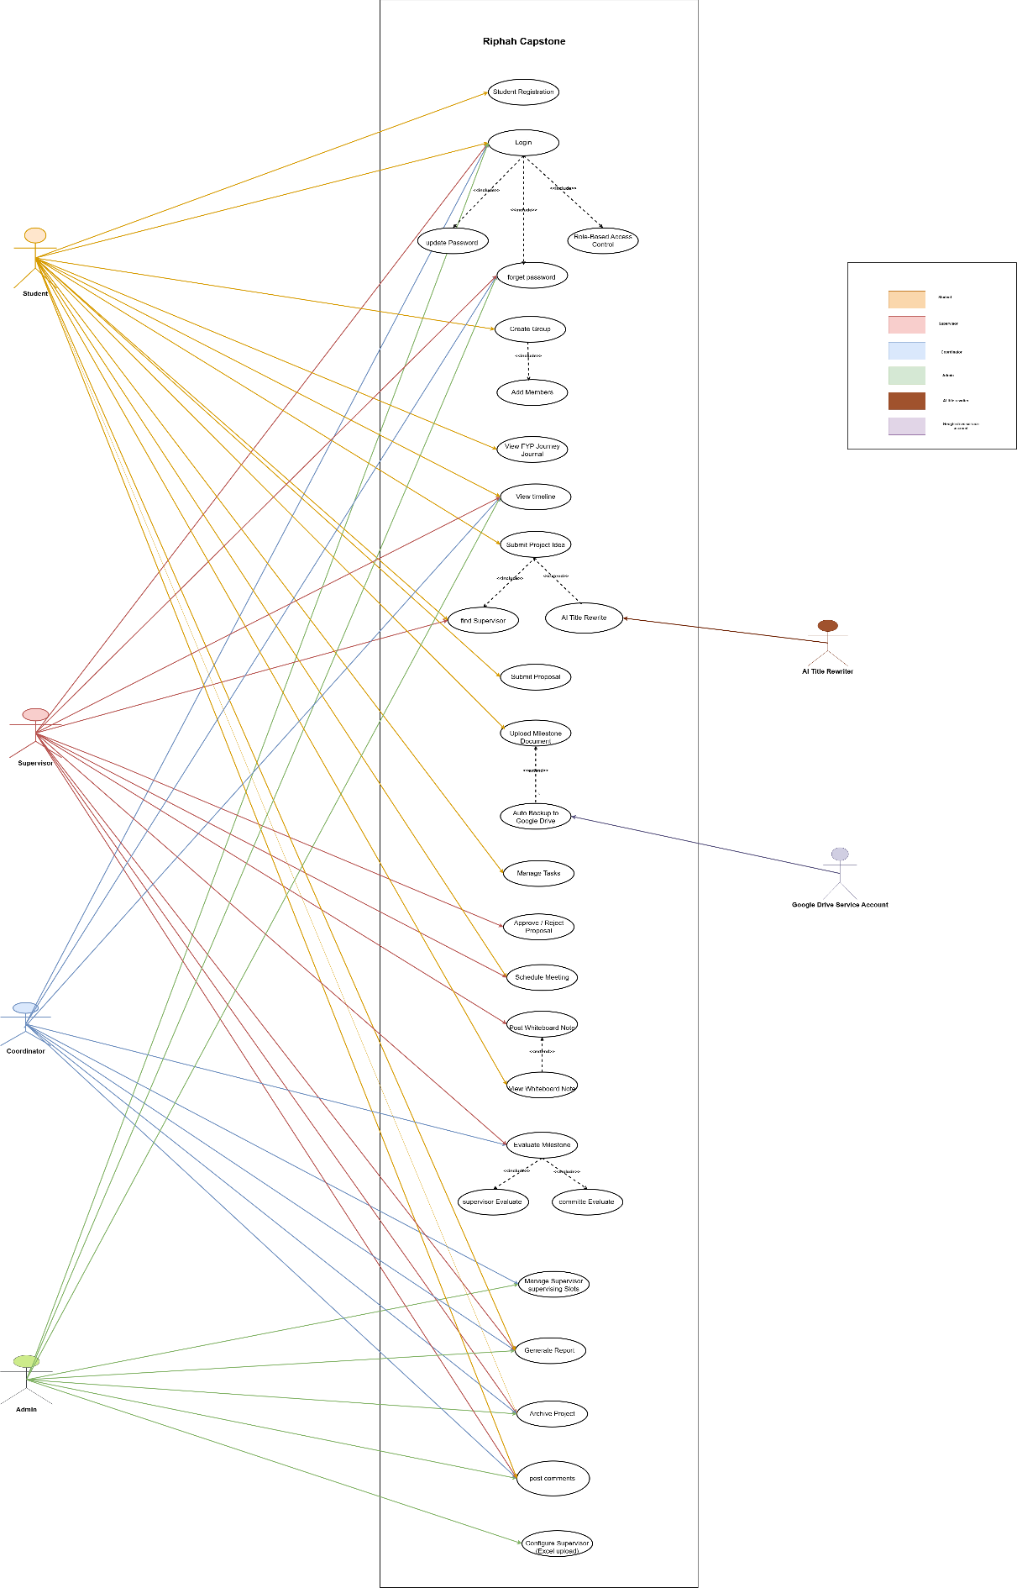
Figure 1Use Case Diagram

4.2.3 Fully Dressed Use Cases

UC-001: Student Registration

Section | Content
Designation | UC-001
Name | Student Registration
Authors | Iman
Priority | High
Criticality | Critical
Source | Project Document
Responsible | System
Description | Allows students to register an account using their institutional email. Supervisors, Coordinators, and Admins are created by the Admin via the Admin Portal.
Trigger event | User selects “Register”.
Actors | Student, Admin
Precondition | User must have a valid institutional email address.
Post condition | A new student account is created and awaits admin approval.
Result | System saves registration details and redirects user to login page.
Main Scenario | - User opens registration page.  - Enters institutional email, name, and password.  - System validates email format and password strength.  - System checks for duplicates.  - System creates new student account.  - User sees “Registration Successful” message and is redirected to login
Alternative Scenario | 3a. Invalid Email → System shows “Invalid Institutional Email”.  3b. Weak Password → System prompts to improve password strength.  4a. Email Already Exists → System shows “Account already exists”.

UC-002: User Login

Section | Content
Designation | UC-002
Name | User Login
Authors | Iman
Priority | High
Criticality | Critical
Source | Project Document
Responsible | System
Description | Allows registered users (Students, Supervisors, Coordinators, Admin) to securely access their dashboards using valid credentials.
Trigger event | User selects “Login”.
Actors | Student, Supervisor, Coordinator, Admin
Precondition | User account must already exist and be approved by the Admin .
Post condition | User is successfully authenticated.
Result | System redirects the user to the appropriate dashboard based on their role.
Main Scenario | - User opens login page.  - Enters institutional email and password.  - System validates credentials.  - If valid, system authenticates and logs the user in.  - Redirects to role-based dashboard.
Alternative Scenario | 3a. Invalid Email → System shows “Invalid Email Format”.  3b. Incorrect Password → System shows “Invalid Credentials”.  3c. Unapproved Student → System shows “Account not approved yet”

UC-003: Update Password

Section | Content
Designation | UC-003
Name | Update Password
Authors | Ayesha Butt
Priority | Medium
Criticality | Medium
Source | Feature 23: Change Password
Responsible | All Users
Description | Allow any user to update password from settings.
Trigger event | User wants to enhance security.
Actors | Student, Supervisor, Coordinator, Admin
Precondition | User is logged in.
Post condition | Password updated successfully.
Result | Next login requires new password.
Main Scenario | 1. User goes to Profile → Change Password. 2. Enters current + new password. 3. System validates and updates. 4. Success message shown.
Alternative Scenario | 2a. Wrong current password → “Incorrect current password.”

UC-004: Forgot Password

Section | Content
Designation | UC-004
Name | Forgot Password
Authors | Iman
Priority | Medium
Criticality | Moderate
Source | Project Document
Responsible | System
Description | Allows users to reset their password securely through a verification email.
Trigger event | User selects “Forgot Password” on the login screen.
Actors | Student, Supervisor, Coordinator, Admin
Precondition | User must have an existing registered email.
Post condition | Password successfully reset.
Result | User can log in with a new password.
Main Scenario | - User clicks “Forgot Password”.  - System asks for registered email.  - User enters email.  - System verifies email and sends reset link.  - User clicks link and sets a new password.  - System confirms reset and redirects to login page.
Alternative Scenario | 3a. Unregistered Email → System shows “Email not found”.  5a. Passwords don’t match → System prompts to re-enter.

UC-005: Role-Based Access Control

Section | Content
Designation | UC-002
Name | Role-Based Access Control (RBAC)
Authors | Iman
Priority | High
Criticality | Critical
Source | Project Document
Responsible | System
Description | Controls system permissions so each user can only access features allowed for their role.
Trigger event | Successful login.
Actors | System, Admin
Precondition | User role exists in the database.
Postcondition | Role permissions applied to session.
Result | User sees only authorized features.
Main Scenario | 1. User logs in.  2. System retrieves user role and related permissions.  3. Loads interface according to allowed access.  4. Blocks restricted actions automatically.
Alternative Scenario | 2a. Role Missing:  1. System finds no assigned role.  2. Displays “Role not assigned, contact admin.”

UC-006: Create Group

Section | Content
Designation | UC-006
Name | Create Group
Authors | Iman
Priority | High
Criticality | Critical
Source | Project Document
Responsible | Student (Leader), System
Description | Enables a student to create a project group with a maximum of three members, making the creator the group leader.
Trigger event | Student selects “Create Group”.
Actors | Student (Leader), System
Precondition | Student logged in and not a member of another group.
Postcondition | Group created successfully with leader assigned.
Result | Group stored in system and visible on dashboard.
Main Scenario | 1. Student opens the “Groups” section.  2. Clicks “Create Group.”  3. Enters group name and description.  4. System validates details.  5. Group created with leader assigned.
Alternative Scenario | 3a. Student Already in Group:  1. System detects membership.  2. Displays message “You already belong to another group.”

UC-007: Add Members

Section | Content
Designation | UC-004
Name | Add Members
Authors | Iman
Priority | High
Criticality | Medium
Source | Project Document
Responsible | Group Leader, System
Description | Allows a group leader to add students to the group until the maximum size limit is reached.
Trigger event | Leader clicks “Add Member”.
Actors | Group Leader, Student, System
Precondition | Group exists and leader authenticated.
Post condition | Member successfully added.
Result | Group updated with new member.
Main Scenario | 1. Leader clicks “Add Member.”  2. Searches for student by ID or email.  3. System validates eligibility.  4. Adds student to group.  5. Notification sent to member.
Alternative Scenario | 3a. Member Already in Another Group:  1. System detects duplication.  2. Displays “Student already in another group.”

UC-008: View FYP Journey Journal

Section | Content
Designation | UC-008
Name | View FYP Journey Journal
Authors | Iman
Priority | Medium
Criticality | Low
Source | Project Document
Responsible | System
Description | Automatically compiles all student activities into a weekly project journal in PDF format.
Trigger event | System’s weekly schedule or user selects “Generate Journal”.
Actors | Student, System
Precondition | Student activities recorded.
Post condition | Journal generated and available for download.
Result | Weekly journal PDF accessible to the student.
Main Scenario | 1. System retrieves weekly activity data.  2. Formats entries chronologically.  3. Generates PDF journal.  4. Provides download link to student.
Alternative Scenario | 2a. No Activities Found:  1. System identifies no logs.  2. Creates “No Activity Recorded” journal placeholder.

UC009: View Timeline

Section | Content
Designation | UC-009
Name | View Timeline
Authors | Ayesha Butt
Priority | High
Criticality | High
Source | Feature 14: Smart Project Readiness Checklist
Responsible | System (Auto), Student
Description | Auto-verify project readiness before final submission.
Trigger event | Student attempts final project submission.
Actors | Student, System
Precondition | All milestones and tasks in progress.
Postcondition | Submission allowed only if checklist passes.
Result | Visual checklist with status icons.
Main Scenario | 1. Student clicks “Submit Final Project”.  2. System checks:  • All milestones approved  • All tasks done  • Final report uploaded  3. Shows checklist with Complete/Incomplete.  4. If all green → Allow submit.  5. Else → Block and highlight missing items.
Alternative Scenario | 3a. One item missing → “Complete [item] before submission.”

UC-010: Submit Project Idea

Section | Content
Designation | UC-010
Name | Submit Project Idea
Authors | Iman
Priority | High
Criticality | Medium
Source | Project Document
Responsible | Student (Group Leader), System
Description | Allows a group leader to submit the team’s project idea including title, domain, abstract, and tools for coordinator and supervisor review.
Trigger event | Leader selects “Submit Project Idea”.
Actors | Student (Leader), System
Precondition | Group created successfully.
Postcondition | Project idea stored for further review.
Result | Idea submission saved successfully.
Main Scenario | 1. Leader opens Project Idea form.  2. Fills in project title, abstract, and domain.  3. System validates required fields.  4. System stores idea and notifies relevant parties.
Alternative Scenario | Missing Details:  System detects empty fields.  Displays “All fields are required.”  User completes missing fields and resubmits.

UC-011: Find Supervisor

Section | Content
Designation | UC-011
Name | Find Supervisor
Authors | Ayesha Butt
Priority | High
Criticality | High
Source | Feature 6: Supervisor Selection & Smart Suggestions
Responsible | Group Leader (Student)
Description | Group selects a supervisor based on domain match, load, and availability.
Trigger event | Group formation and idea submission completed.
Actors | Student
Precondition | Group is formed; project idea submitted.
Postcondition | Supervisor selected; proposal sent for approval.
Result | Supervisor receives proposal; availability updated.
Main Scenario | 1. Group leader goes to “Select Supervisor”.  2. System shows list with: Domain Match %, Load (e.g., 3/5), Availability.  3. Leader selects one supervisor.  4. System sends proposal and locks selection.
Alternative Scenario | 3a. All supervisors full → Show “No slots available. Contact Coordinator.”

UC-012: AI Title Rewriter

Section | Content
Designation | UC-012
Name | AI Title Rewriter
Authors | Iman
Priority | Medium
Criticality | Low
Source | Project Document
Responsible | System (AI Module)
Description | Suggests improved or professional versions of a project title using AI.
Trigger event | Student selects “Rewrite Title with AI”.
Actors | Student, System
Precondition | A draft title is entered.
Postcondition | Final refined title saved.
Result | Title improved and updated in system.
Main Scenario | 1. Student inputs rough project title.  2. System sends title to AI module.  3. AI returns multiple professional suggestions.  4. Student selects preferred title.  5. System saves chosen title.
Alternative Scenario | Suggestions Rejected:  Student opts to keep original title.  System retains initial entry.

UC-013: Submit Proposal
Section | Content
Designation | UC-013
Name | Submit Proposal
Authors | Iman
Priority | High
Criticality | High
Source | Project Document
Responsible | Student, System
Description | Students upload their finalized proposal document using the official template; file becomes locked after submission.
Trigger event | Student clicks “Submit Proposal”.
Actors | Student, Supervisor, System
Precondition | Supervisor assigned; proposal prepared in correct template.
Postcondition | Proposal stored and locked for review.
Result | Supervisor notified of new submission.
Main Scenario | 1. Student uploads proposal.  2. System validates template format.  3. Locks file.  4. Notifies supervisor for review.
Alternative Scenario | Invalid File Format:  System rejects upload.  Displays “Invalid template or file type.”  Student reuploads correct version.

UC-014: Upload Milestone Document

Section | Content
Designation | UC-014
Name | Upload Milestone Document
Authors | Iman
Priority | High
Criticality | High
Source | Project Document
Responsible | Student, System
Description | Allows students to upload milestone documents (SRS, Design, Final Report) using the provided template before the deadline.
Trigger event | Student selects “Upload Milestone”.
Actors | Student, Supervisor, System
Precondition | Template downloaded and deadline not passed.
Postcondition | File uploaded successfully and sent for review.
Result | Milestone submission recorded in the system.
Main Scenario | 1. Student selects milestone.  2. Uploads completed document.  3. System validates file format and size.  4. Upload stored and supervisor notified.
Alternative Scenario | Deadline Passed:  System rejects submission.  Displays “Deadline exceeded.”

UC-015: Auto Backup to Google Drive

Section | Content
Designation | UC-015
Name | Auto Backup to Google Drive
Authors | Iman
Priority | Medium
Criticality | Medium
Source | Project Document
Responsible | System (Google Drive Service Account)
Description | Automatically backs up student submissions to a departmental Google Drive using a service account.
Trigger event | Successful milestone upload.
Actors | System, Google Drive Service Account
Precondition | Drive connection configured.
Post condition | File backed up to Drive.
Result | Backup stored in department folder.
Main Scenario | 1. System uploads file to Drive.  2. Generates backup link.  3. Stores link with record.
Alternative Scenario | Upload Fails:  System retries upload.  Logs failure and alerts admin if persistent.

UC-016: Manage Tasks

Section | Content
Designation | UC-016
Name | Manage Tasks
Authors | Iman
Priority | Medium
Criticality | Low
Source | Project Document
Responsible | Student, System
Description | Allows group members to create and manage tasks within their project’s To-Do Tracker.
Trigger Event | Group member selects “Add Task”.
Actors | Student (Group Member), System
Precondition | Group formed and active.
Postcondition | Task successfully saved.
Result | Task added and visible in task list.
Main Scenario | 1. Member opens task panel.  2. Enters title, assignee, and status.  3. System validates input and saves.  4. Task appears in list.
Alternative Scenario | 2a. Empty Fields:  1. System prompts completion.  2. User fills details and resubmits.

UC-017: Approve / Reject Proposal

Section | Content
Designation | UC-017
Name | Approve / Reject Proposal
Authors | Iman
Priority | High
Criticality | High
Source | Project Document
Responsible | Supervisor, System
Description | Enables supervisors to review student proposals and approve or reject them with feedback.
Trigger Event | Supervisor opens proposal review.
Actors | Supervisor, Student, System
Precondition | Proposal uploaded by student.
Postcondition | Proposal status updated.
Result | Approval or rejection recorded and group notified.
Main Scenario | 1. Supervisor opens proposal document.2. Reviews content.3. Clicks “Approve” or “Reject.”4. System updates status and notifies group.
Alternative Scenario | 3a. Proposal Rejected: 1. Supervisor enters feedback. 2. System marks proposal as “Rejected.” 3. Student revises and resubmits.

UC-018: Schedule Meeting

Section | Content
Designation | UC-018
Name | Schedule Meeting
Authors | Iman, [Other authors]
Priority | Medium
Criticality | Medium
Source | Student / Supervisor
Responsible | Student / Supervisor
Description | Allows students or supervisors to schedule project meetings.
Trigger Event | Need for discussion/feedback.
Actors | Student, Supervisor
Precondition | Student registered for project.
Postcondition | Meeting scheduled and participants notified.
Result | Participants attend scheduled meeting.
Main Scenario | 1. Actor logs in.  2. Navigates to “Schedule Meeting”  .3. Selects date/time.  4. Invites participants.  5. System confirms schedule.  6. Notifications sent.
Alternative Scenario | 1a. Date/time conflict: System prompts for alternative.  2a. Participants decline: Reschedule requested.

UC-019: Post Whiteboard Note

Designation | UC-019
Name | Post Whiteboard Note
Authors | Ayesha Butt
Priority | High
Criticality | Medium
Source | Feature 12: Whiteboard Sharing
Responsible | Supervisor
Description | Supervisor posts instructions, feedback, or notes on a virtual whiteboard visible to group members.
Trigger event | Supervisor needs to communicate important information to the group.
Actors | Supervisor
Precondition | Supervisor is logged in and assigned to a group.
Postcondition | Note is saved and instantly visible on students’ dashboards.
Result | Students see the formatted note under their project section.
Main Scenario | 1. Supervisor selects the group.  2. Navigates to Whiteboard section.  3. Types note with optional formatting (bold, color).  4. Clicks “Post”.  5. System saves and pushes note to group dashboard.
Alternative Scenario | 3a. If note is blank → Show error: “Note cannot be empty”.  4a. If no group selected → Prompt to select group.

UC-020: View Whiteboard Note

Section | Content
Designation | UC-020
Name | View Whiteboard Note
Authors | Ayesha Butt
Priority | High
Criticality | Medium
Source | Feature 12: Whiteboard Sharing
Responsible | Student
Description | Students view supervisor-posted notes on their project dashboard.
Trigger event | Student logs in or refreshes dashboard.
Actors | Student
Precondition | Student is part of a group with an assigned supervisor.
Postcondition | Latest notes are displayed in real-time.
Result | Notes appear formatted and in chronological order.
Main Scenario | 1. Student logs into dashboard.  2. System loads project section.  3. All whiteboard notes from supervisor are displayed.  4. Student reads the content.
Alternative Scenario | 3a. No notes posted → Display “No notes from supervisor yet.”

UC-021: Evaluate Milestone

Section | Content
Designation | UC-021
Name | Evaluate Milestone
Authors | Ayesha Butt
Priority | High
Criticality | High
Source | Feature 15: Evaluation Module (Rubric-Based)
Responsible | Supervisor
Description | Supervisor grades milestone using rubric and provides feedback.
Trigger event | Student submits a milestone (Proposal, SRS, etc.).
Actors | Supervisor
Precondition | Milestone uploaded and pending review.
Postcondition | Grade calculated; feedback saved; students notified.
Result | Students see score breakdown and comments.
Main Scenario | 1. Supervisor opens submitted milestone. 2. Fills rubric marks and adds comments per criterion. 3. System auto-calculates total score. 4. Supervisor submits evaluation. 5. Students receive notification and view results.
Alternative Scenario | 2a. Incomplete rubric → “All fields required”. 4a. Draft save available before final submit.

UC-022: Committee Evaluate

Section | Content
Designation | UC-024
Name | Committee Evaluate Project
Authors | SanaArshad
Priority | High
Criticality | Critical
Source | Feature 15: Evaluation Module (Rubric-Based)
Responsible | Evaluation Committee, System
Description | Enables the evaluation committee to assess final student projects during the defense phase using standardized rubrics. The system records each member’s marks and computes the overall weighted grade automatically.
Trigger event | Committee session begins, and evaluators open the assigned project for assessment.
Actors | Committee Members, System, Coordinator
Precondition | Final project submission and supervisor evaluation must be completed. Committee members must have evaluation access.
Post condition | Final evaluation scores and feedback are stored, averaged, and made viewable to the supervisor, coordinator, and student.
Result | Committee evaluation successfully submitted; final marks locked and reflected in dashboards and reports.
Main Scenario | 1. Coordinator schedules committee evaluation.  2. Committee logs in and opens assigned project.  3. System displays rubric criteria (Presentation, Implementation, Documentation, Viva, etc.).  4. Each member enters marks and feedback.  5. System averages and records total score.  6. Final grade generated and locked after confirmation.
Alternative Scenario | 3a. Missing Rubric Fields → System highlights unfilled criteria.  4a. Member absent → Coordinator assigns proxy or averages existing evaluations.  5a. Network error → Temporary local save and auto-retry on reconnect.

UC-023: Supervisor Milestone

Section | Content
Designation | UC-023
Name | Supervisor Milestone Management
Authors | Ayesha Butt
Priority | High
Criticality | High
Source | Feature 10 – Project Timeline & Milestone Tracker
Responsible | Supervisor
Description | Allows supervisors to view, track, and manage project milestones for all assigned groups. Supervisors can mark milestones as completed, provide feedback, and monitor deadlines.
Trigger event | Supervisor logs in and selects “View Milestones” or “Manage Milestones.”
Actors | Supervisor, System
Precondition | Supervisor must be assigned to at least one active group.
Postcondition | Milestone statuses updated and synchronized across dashboards.
Result | Supervisor can successfully update or view each group’s milestone progress.
Main Scenario | 1. Supervisor opens the milestone tracker.  2. System displays milestones for all assigned groups.  3. Supervisor reviews progress status (Pending, Completed, Overdue).  4. Supervisor can update status or add feedback.  5. System saves updates and refreshes progress view.
Alternative Scenario | 3a. No Active Groups: System shows “No active projects assigned.”  4a. Unauthorized Update: System restricts milestone editing to assigned groups only.

UC-024: Manage Supervision Slots

Section | Content
Designation | UC-024
Name | Manage Supervision Slots
Authors | Ayesha Butt
Priority | Medium
Criticality | Medium
Source | Feature 24: Supervisor Slots Management
Responsible | Coordinator, Admin
Description | Set maximum number of groups per supervisor.
Trigger event | Need to control supervisor workload.
Actors | Coordinator, Admin
Precondition | User has admin/coordinator access.
Postcondition | Slot limit updated; reflects in selection UI.
Result | Supervisors marked “Full” when limit reached.
Main Scenario | 1. User goes to Supervisor Management.  2. Selects a supervisor.  3. Sets max groups (e.g., 3).  4. Saves changes.  5. System updates availability status.
Alternative Scenario | 3a. Invalid number (<1) → Error: “Enter valid slot count.”

UC-025: Generate Report

Section | Content
Designation | UC-025
Name | Generate Report
Authors | Ayesha Butt
Priority | Medium
Criticality | Medium
Source | Feature 20: Reporting Module
Responsible | All Roles (Role-Based Scope)
Description | Generate and download progress reports in PDF/Excel.
Trigger event | User needs documented proof of progress.
Actors | Admin, Coordinator, Supervisor, Student
Precondition | User has access to relevant data.
Postcondition | Report file downloaded.
Result | File contains milestones, tasks, grades, feedback.
Main Scenario | 1. User selects “Generate Report”  2. Chooses scope (personal/group/department).  3. Selects format (PDF/Excel).  4. System generates and downloads file.
Alternative Scenario | 2a. No data → “No records found for selected scope.”

UC-026: Archive Project

Section | Content
Designation | UC-026
Name | Archive Project
Authors | Ayesha Butt
Priority | Medium
Criticality | Low
Source | Feature 19: Project Archive & Search
Responsible | System
Description | Auto-archive completed projects for future reference.
Trigger event | Final evaluation and grading completed.
Actors | System
Precondition | Project status = “Evaluated”.
Postcondition | Project added to read-only archive.
Result | Searchable by title, tech, supervisor.
Main Scenario | 1. System detects project completion. 2. Extracts: Title, Abstract, Tech, Supervisor, Students. 3. Stores in archive database. 4. Enables search for all users.
Alternative Scenario | 2a. Missing data → Log error for Admin.

UC-027: Post Comments

Section | Content
Designation | UC-027
Name | Send / Receive Notifications (Noticeboard)
Authors | Ayesha Butt
Priority | High
Criticality | Medium
Source | Feature 21: Noticeboard
Responsible | Coordinator (Send), All (Receive)
Description | Post and view system-wide or targeted announcements.
Trigger event | Important update or deadline change.
Actors | Coordinator, All Users
Precondition | Coordinator logged in to post; users logged in to view.
Postcondition | Notice posted and visible to target audience.
Result | Notices shown in descending order (newest first).
Main Scenario | 1. Coordinator creates notice (title, body, scope).  2. Selects visibility: All / Students / Dept.  3. Posts notice.  4. System displays on relevant dashboards.
Alternative Scenario | 2a. Invalid scope → Default to “All”. 4a. No internet → Cache and sync later.

UC-028: Configure supervisor (Excel Upload)

Section | Content
Designation | UC-028
Name | Configure supervisor(Excel Upload)
Authors | Ayesha Butt
Priority | Medium
Criticality | Medium
Source | Feature 22: Excel Upload
Responsible | Admin
Description | Bulk import Supervisors/Coordinators via Excel.
Trigger event | Onboarding multiple faculty at semester start.
Actors | Admin
Precondition | Admin logged in; Excel template downloaded.
Postcondition | Users created with temp passwords.
Result | Success/failure report shown.
Main Scenario | 1. Admin downloads template.  2. Fills data (Name, Email, Role, Dept).  3. Uploads file.  4. System validates and creates accounts.  5. Shows summary: X created, Y failed.
Alternative Scenario | 3a. Wrong format → “Invalid file. Use template.”  4a. Duplicate email → Skip and list in report.

4.3 Architectural Design
4.3.1 Overview
The architectural design represents the high-level structure of the Riphah Capstone System. It is based on a three-tier architecture consisting of the Presentation Layer, Business Layer, and Data Layer.
4.3.2 System Architecture Diagram
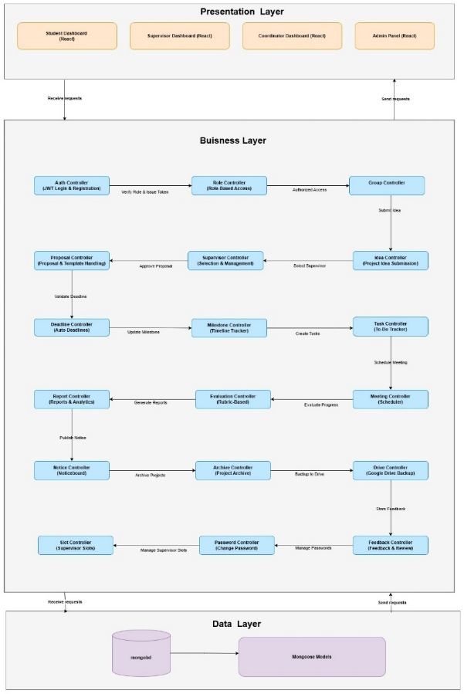
The system follows a three-tier architecture consisting of the Presentation Layer (React.js), Business Layer (Node.js + Express), and Data Layer (MongoDB +Mongoose). The diagram below illustrates how these layers interact to manage user requests, system logic, and database operations efficiently.
Figure 2 Archtecture diagram

4.3.3 JSON Tree Representation
JSON tree represents the hierarchical structure of system modules and data entities in the Riphah Capstone application
.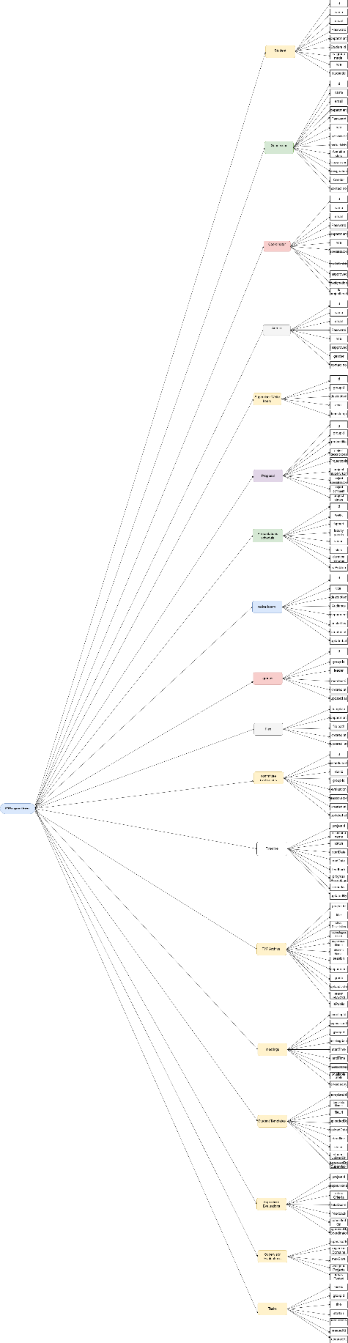
Table 2 json tree diagram

4.3.4 Package Diagram
Package diagram illustrates how different system components and modules are organized logically into packages for better maintainability and modular development.
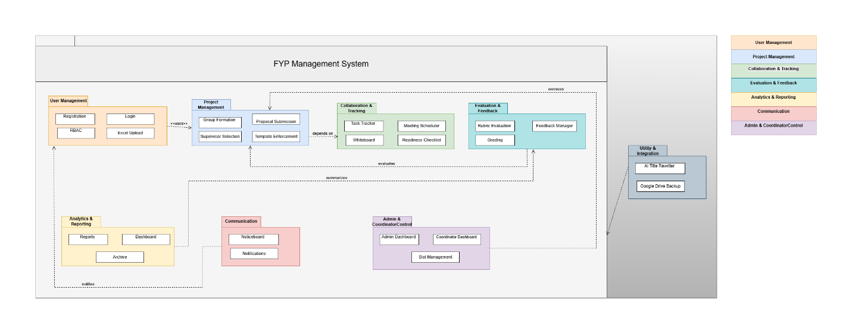
Figure 3 package diagram

4.3.5 Deployment Diagram
The deployment diagram shows the physical architecture of the system how the web application, server, and database are deployed and communicate with each
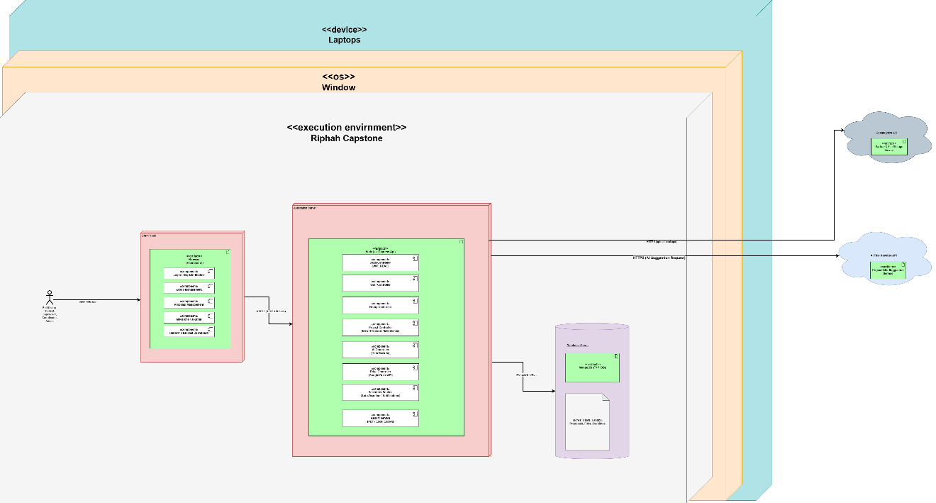
Figure 4 Deployment Diagram

4.4 Detailed Design
4.4.1 Overview
The detailed design provides a closer look at how data flows within the system and how processes interact. It explains the logical movement of data between users, controllers, and the database.
4.4.2 Activity Diagram
The activity diagram illustrates the overall workflow of user actions and system processes in the Riphah Capstone system, showing how activities and decisions flow from start to completion.
(This part is included in Appendix B.)

Chapter 5:

Implementation

Chapter 5:
Implementation

5.1 Endeavour (Team + Work + Way of Working)

5.1.1Team
      - Sana Arshad
      - Iman Arshad
      - Ayesha Butt

5.1.2 Work
      - Planning
      - Requirement Gathering
      - Designing
      - Implementation
      - Testing

5.1.3 Way of working
In every part of the Software Development Life Cycle or SDLC, there are different things we do to make sure the project goes well. We're going to describe what we do in each part of the process and how everyone in the team works together to make it happen.

5.1.3.1 Planning

Planning | Implemented by
Develop Plan | Sana Arshad
Design Plan | Iman Arshad
Review Plan | Ayesha Butt
Table 3Planning

5.1.3.2 Requirements Gathering
Requirements Gathering | Implemented by
Elicit and document requirements | Iman Arshad
Literature review | Sana Arshad,iman arshad ,Ayesha B utt
Table 4Requirements Gathering

5.1.3.3 Designing

Designing | Designed by
Deployment  Diagram, Activity diagram | Iman Arshad
Package Diagram, Activity diagram, | Sana Arshad
Usecase Diagram, Activity diagram | Ayesha Butt
Table 5Designing

5.1.3.4 Implementation
Implementation | Implemented by
Student Panel | Sana Arshad
Supervisor panel | Iman Arshad
Coordinator / Admin Panel | Ayesha Butt
Table 6 Implementation

5.1.3.5. Testing

Testing | Implemented by
Build Scenarios, Test cases | Sana Arshad
Build Scenarios, Test cases | Iman Arshad
Build Scenarios, Test cases | Ayesha Butt
Table 7 Testing

5.2 Flow Control/Pseudo codes
A flowchart is a visual representation of a series of steps, presenting them in a sequential order. It is widely used in presenting the flow of algorithms, workflow or processes. Typically, a flowchart shows the steps as various types of boxes, and their sequence is indicated by connecting them with arrows.
5.2.1 Student Flow Control
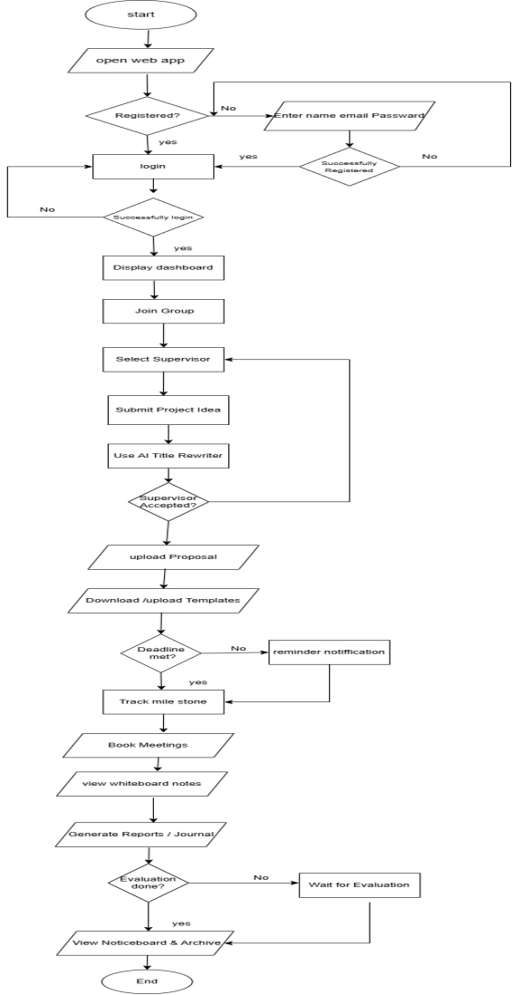
Figure 5 student flowcontrol

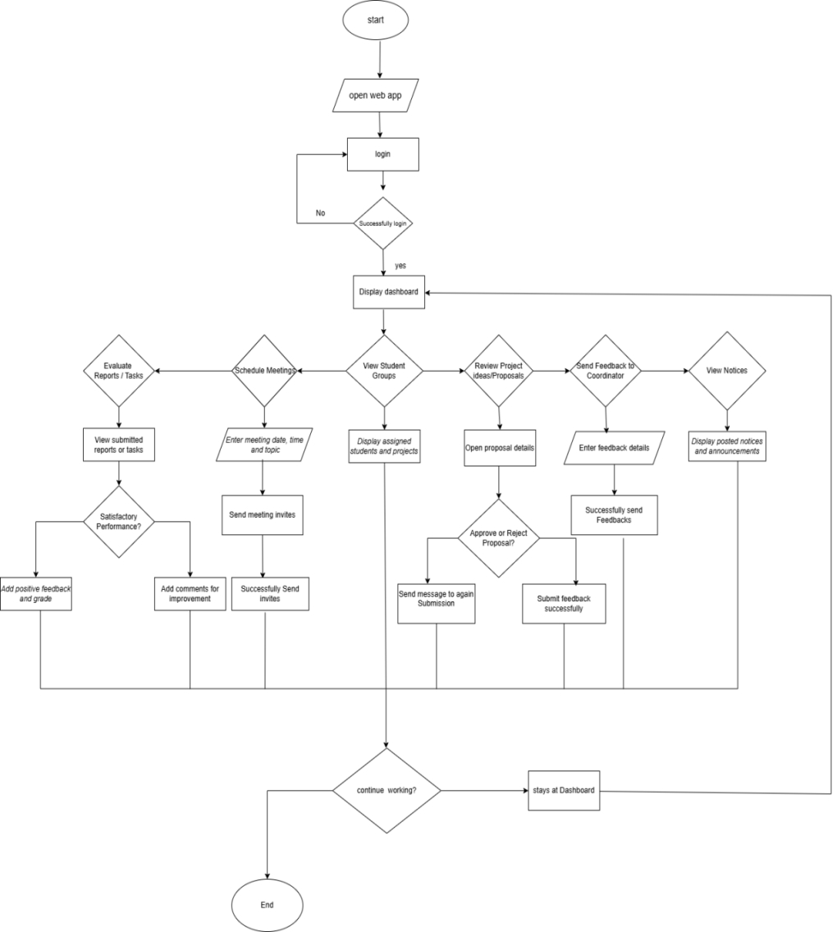
5.2.2 Supervisor Flow Control
Figure 6 Supervisor flow control

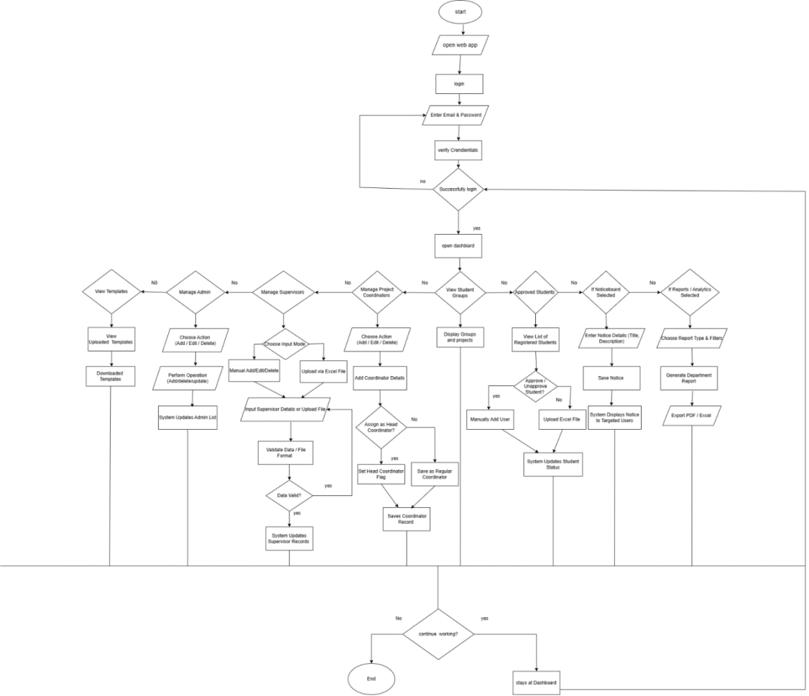
5.2.3 Admin Flow Control
Figure 7 admin flow control

5.2.4 Project Coordinator Flow Control
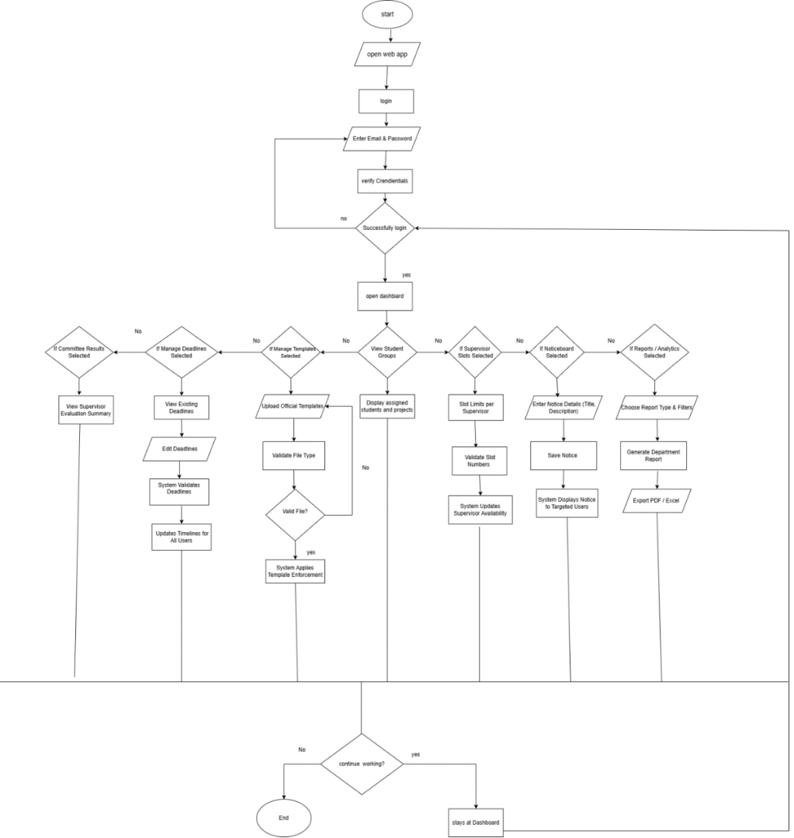
Figure 8Project Coordinator Flow Control

5.3 Components, Libraries, Web Services, and Stubs
Components and libraries are sets of pre-made, tested, and well-documented UI components that can be easily reused by integrating them across the user interface of a system.

Frameworks
      - React Js
      - React Router
      - Express.Js
      - Node.Js

Web Libraries/ API’s Components
      - Font awesome
      - React
      - Rest api
      - CORS
      - Dotenv
      - Multer
      - Axios
      - Mongoose

External Libraries/ API’s / Services
      - MongoDB (Non-relational database)

Languages
      - JavaScript (JSX)
      - MERN Stack
      - React.js
      - HTML
      - CSS

Platforms/ Tools
To develop the system, following tools are used by the team members:
      - Visual Studio Code
      - Microsoft Teams
      - GitHub
      - Microsoft Word
      - Microsoft PowerPoint
      - Google Form
      - Draw.io
      - MongoDBCompass

5.4 Best Practices / Coding Standards

React:

Organize components logically

Prioritize functional components

Utilize hooks like useState and useEffect

Use consistent and meaningful names

Design for different devices
        - Implement responsive components

Node.js and Express:
- Modular code structure (controller, routes, server)
- Asynchronous programming
- Middleware separation
- Environment variables in dotenv file
- Error Handling

MongoDB (database):
- Schema Design Using mongoose
- Handle Database Connection

5.3 Deployment Environment
The Riphah Capstone is a web-based platform developed to automate and streamline the management of Final Year Projects (FYPs) in universities. It removes manual inefficiencies such as record mismanagement, coordination gaps, and delayed evaluations by bringing all stakeholders together on one platform.
The frontend, built with React.js, provides a responsive and user-friendly interface. The backend, developed using Node.js and Express.js, handles authentication, APIs, and system logic securely. Configuration details are managed through the .env file.
The system is currently under development, with deployment planned for the next semester (FYP-II) on cloud platforms like Heroku or AWS.

Software Requirements:

Software | Requirement
Integrated Development Environment | Visual Studio Code
Application Programming Interface | Rest API, React API, Gmail
Programming languages | React Native, React Js and MERN Stack
Database | No SQL (MongoDB)
Package Manager | NPM, Create React App, React Router,  Material-UI, Create React Native App
Version Control System | Git, Github
Table 8 Software Requirements

5.4 Summary
In Chapter 5, the team’s workflow, task allocation, and technical implementation of the Riphah Capstone have been described. Each member (Sana Arshad, Iman Arshad, and Ayesha Butt) contributed to planning, requirements gathering, designing, implementation, and testing. Only the actual methods used, modules, and features of the project are documented. Frameworks, libraries and coding standards are also explained. This chapter provides a complete picture of how the team developed, structured, and prepared the system for future deployment.

Chapter 6:

Testing and Evaluation

Chapter 6: Testing and Evaluation

6.1 Introduction
This chapter presents the testing and evaluation process of the Riphah Capstone Project Management System. The main purpose of testing was to verify that all modules and features of the system function correctly and meet the specified requirements. Various testing methods, including functional, usability, and performance testing, were performed to ensure that the system operates smoothly for all four stakeholders Students, Supervisors, Coordinators, and Admin.
The testing also focused on validating role-based access control, secure authentication, workflow accuracy, and proper integration among different modules such as group formation, proposal submission, milestone tracking, evaluation, and reporting.

6.2 List of Test Scenarios
The lists of test scenarios considered for the project are:
See Appendix C: Testing

6.3 Performance and Evaluation
The system’s performance was evaluated through several key parameters including response time, data accuracy, and user feedback. During testing, the average page load time remained under 3 seconds, which indicates efficient system performance.
User Experience & Functionality:
The interface was clean and intuitive, with smooth navigation for group creation, supervisor selection, and milestone tracking. AI title rewriting and automatic deadline checks were well received.

Security & Performance:
Email validation, password rules, and role-based access worked effectively, blocking unauthorized attempts. All modules functioned correctly, handled multi-department data efficiently, and ensured file safety via auto backup and Google Drive integration.

User Feedback:
Students tracked tasks easily; supervisors liked evaluation and scheduling tools; coordinators valued analytics and reporting; admins appreciated bulk uploads and user management.

6.4 Summary
This chapter discussed the comprehensive testing and evaluation process of the Riphah Capstone Project Management System. The system was tested under different conditions to ensure reliability, usability, and accuracy. All test cases passed successfully, demonstrating that the system fulfills its intended purpose of managing final year projects efficiently. Performance results and user feedback confirmed that the platform is stable, user-friendly, and ready for deployment.

Appendix B:

Design Documents

ACTIVITY DIAGRAMS

1.login/register

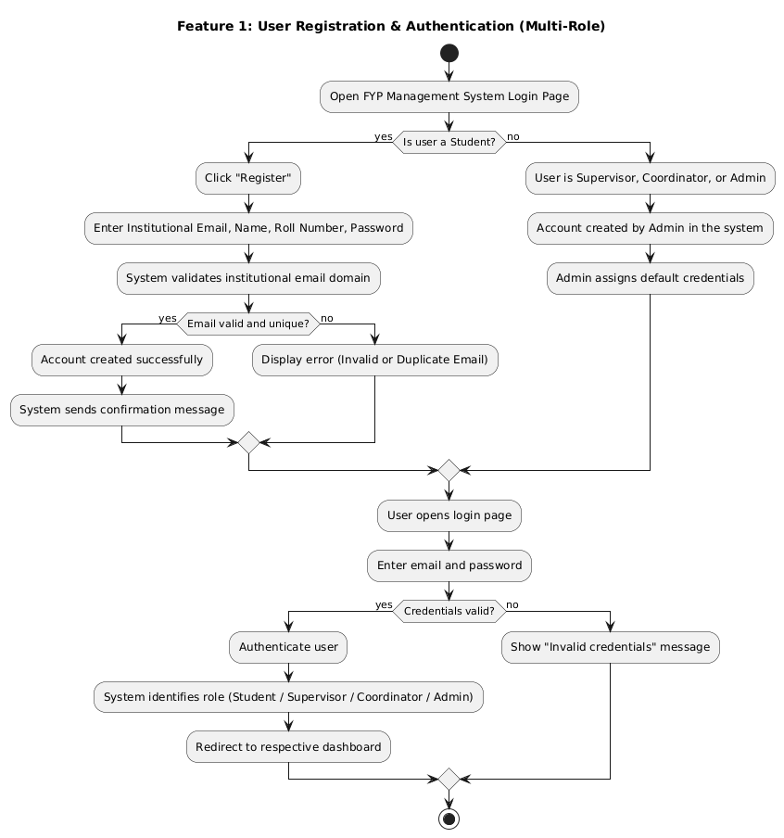

2. Role-Based Access Control

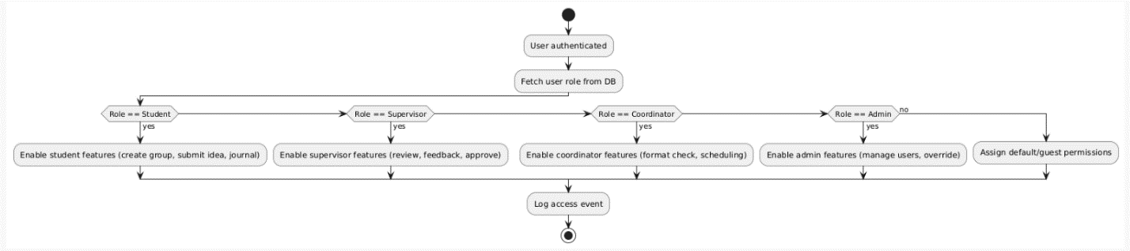

3.Group Formation

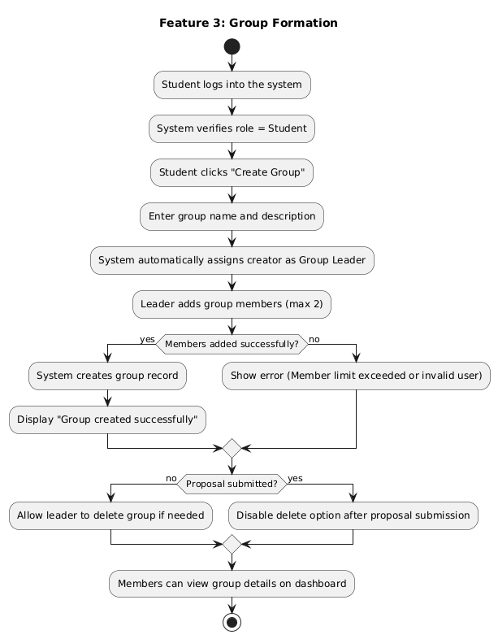

4.Add members 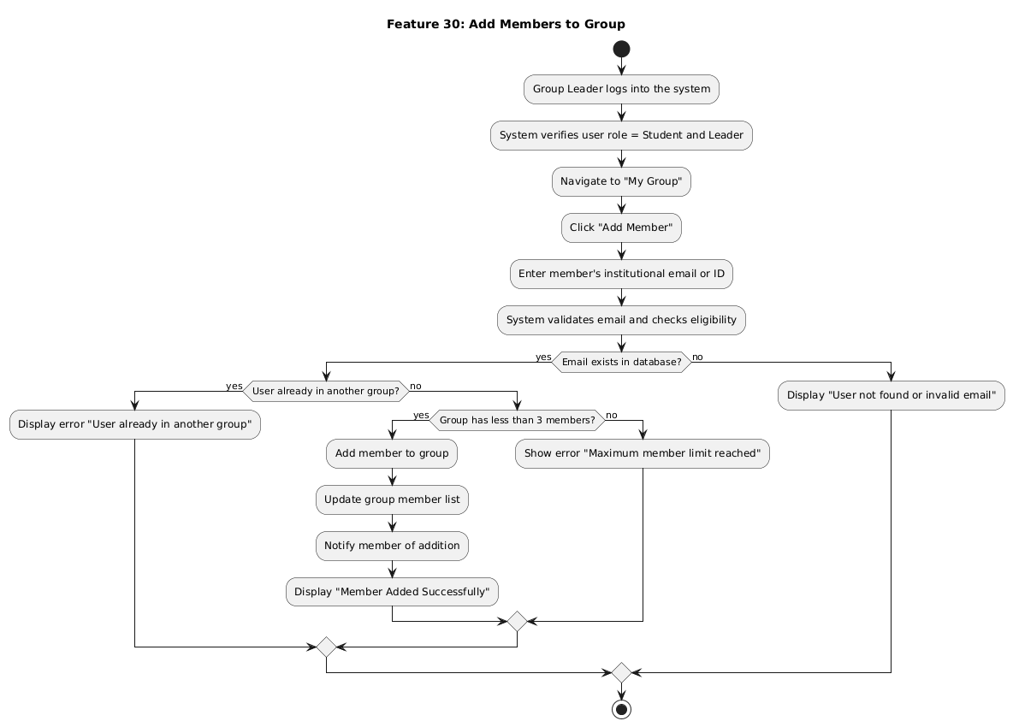

5.Fyp journey journel

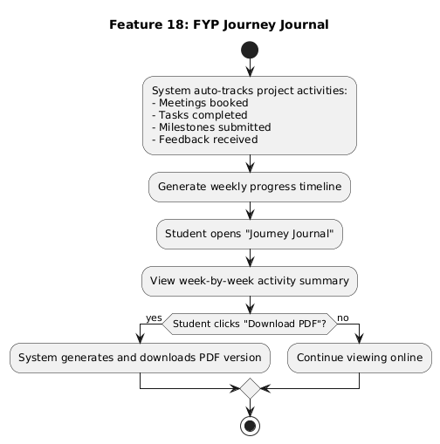

6.Submit project idea

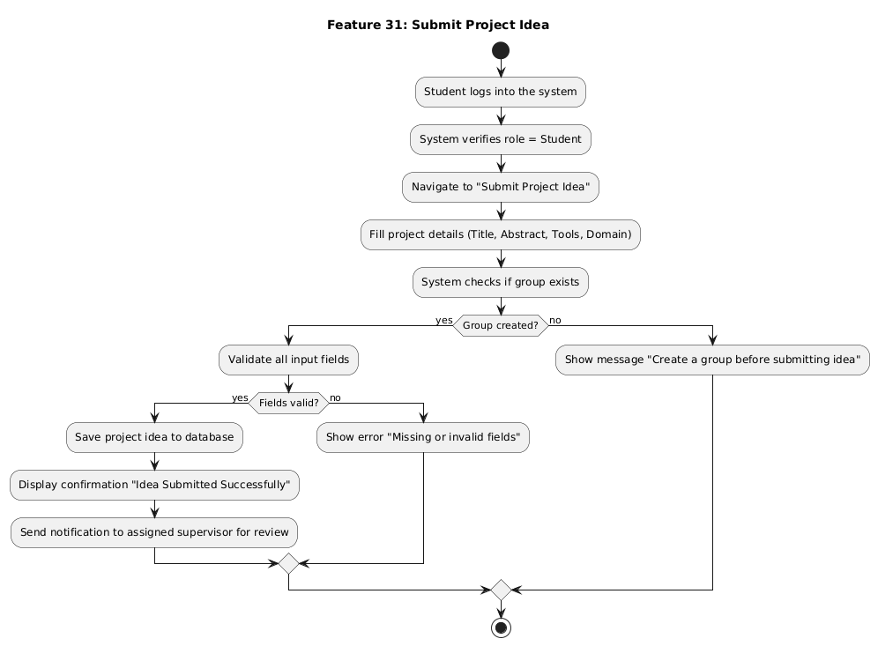

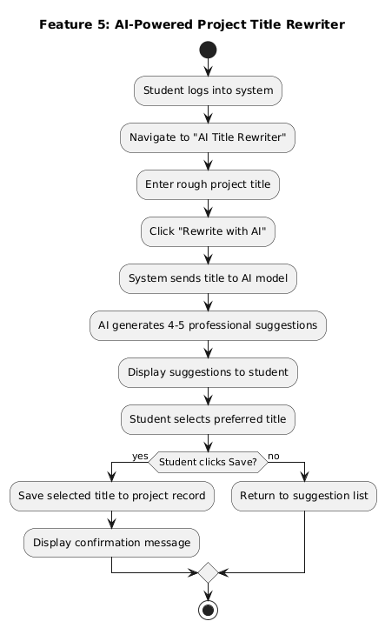
7.Ai title rewrite

8.Submit proposal

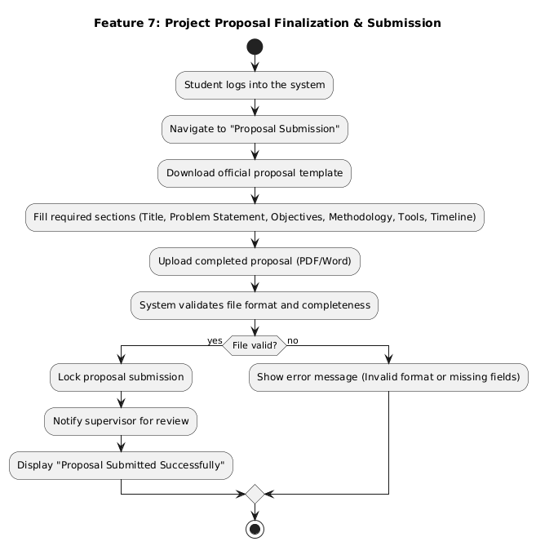

9.Download template

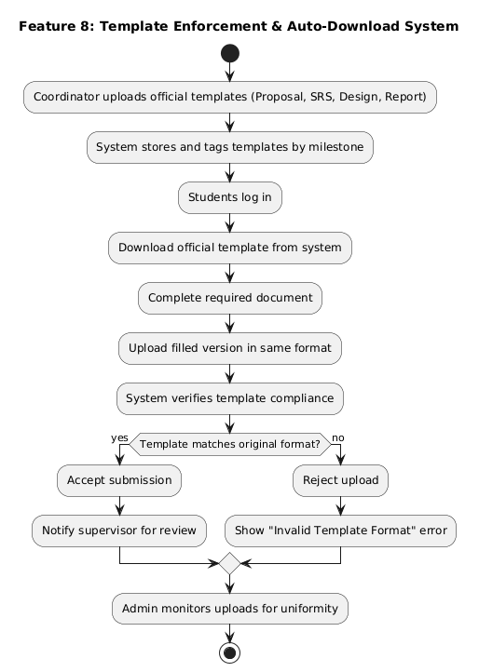

10.Auto deadline check
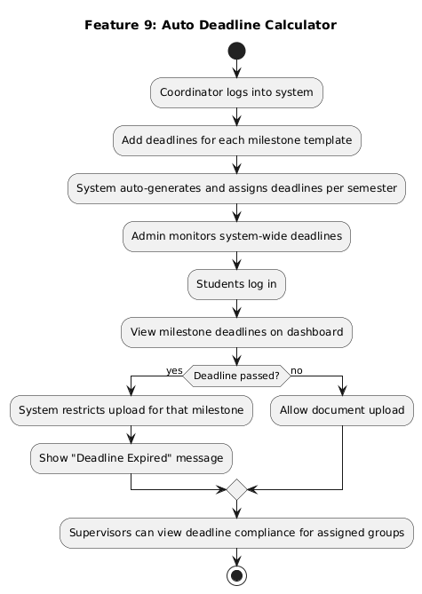

11.Auto backup to Google drive

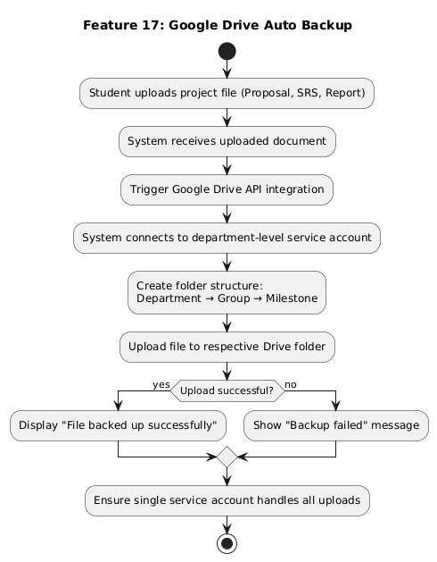

12.Add task
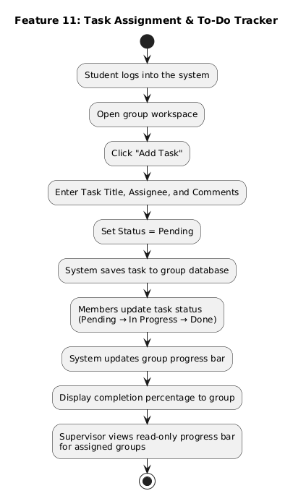

13. Approve/Reject proposal

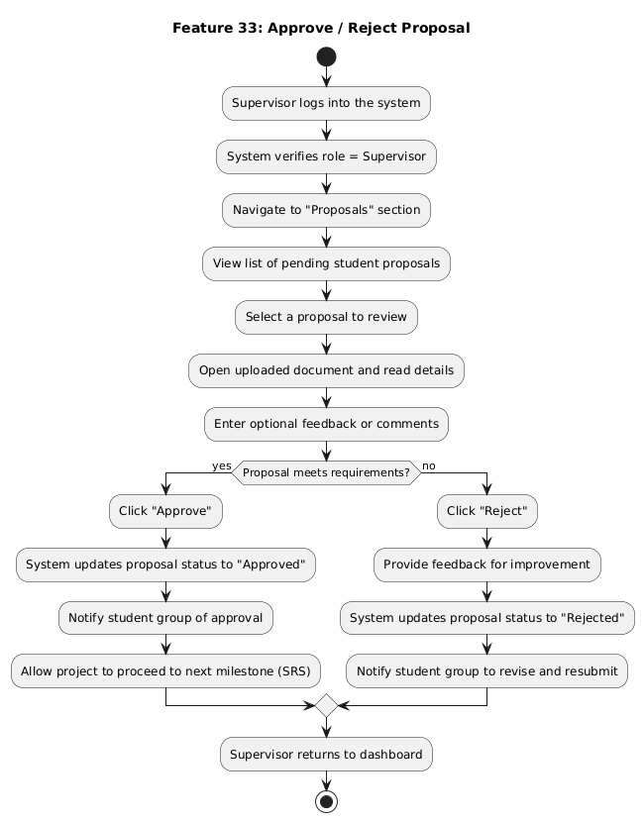

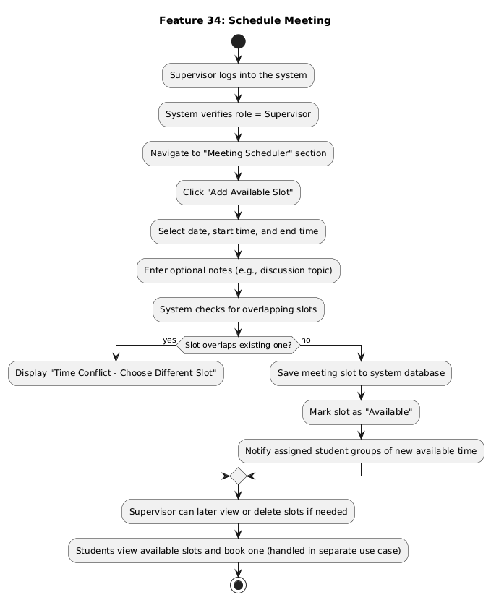
14.Schedule meeting

15.Post Whiteboard
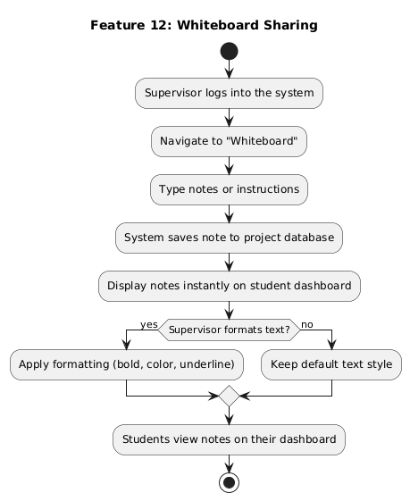

16.View White board

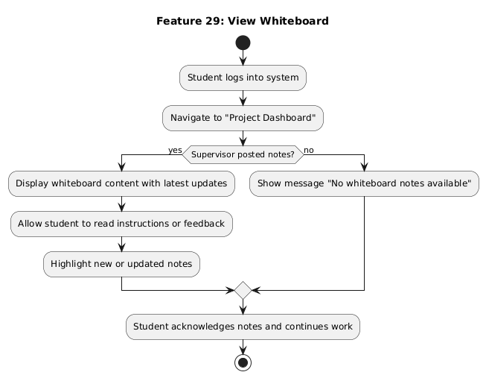

17.Select Supervisor
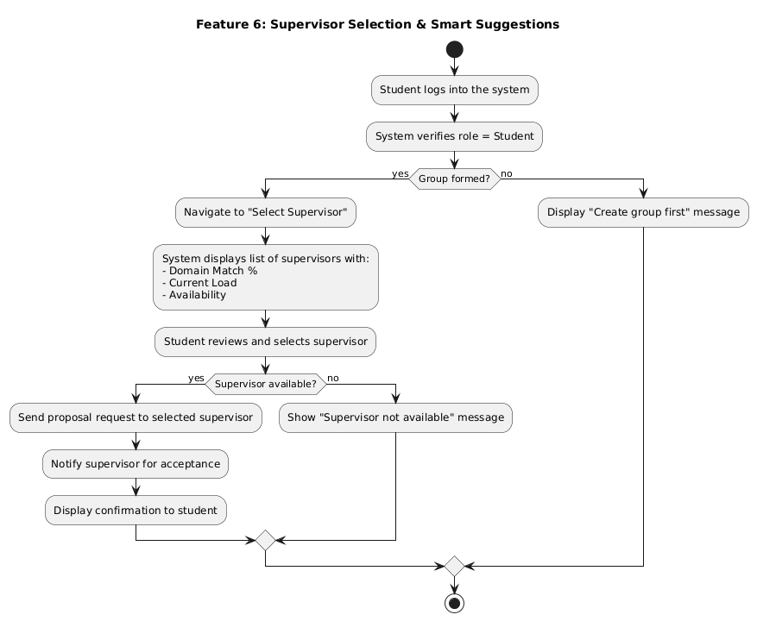

18.Manage Supervisor Slots
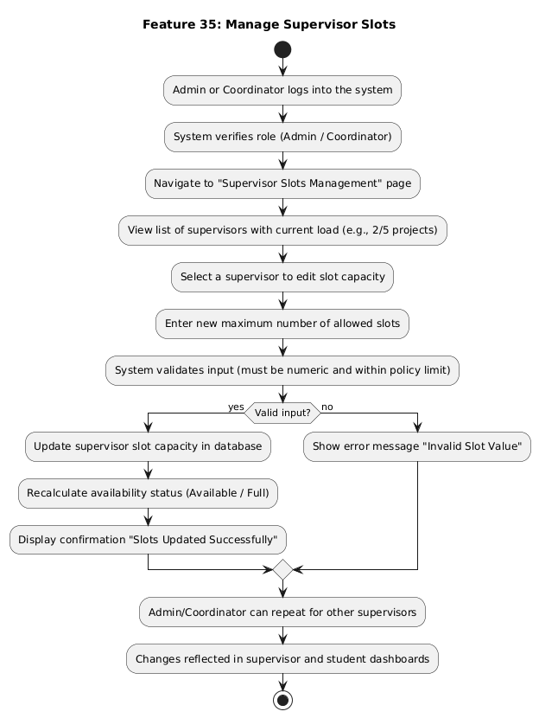

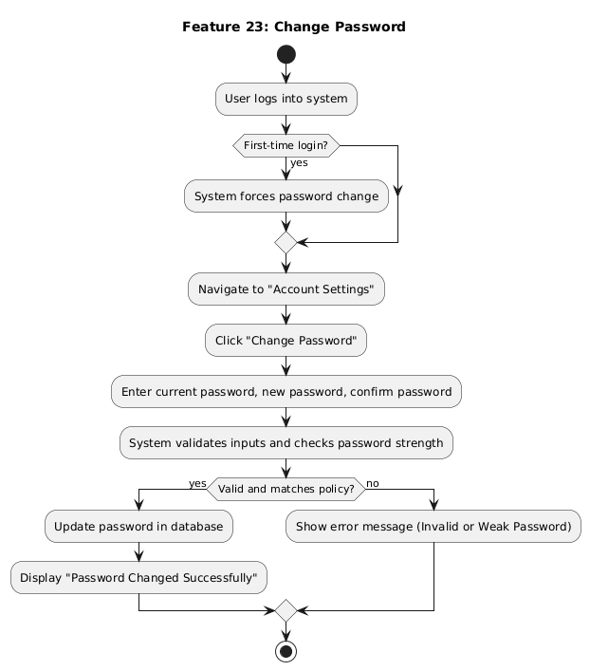
19.Change Password

20.Generate Report

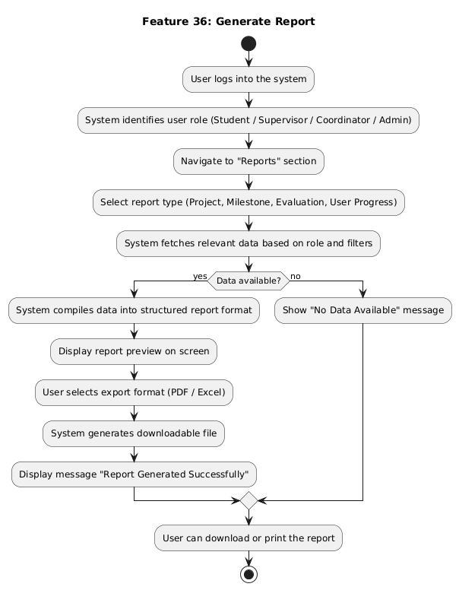

21.Rediness Checklist

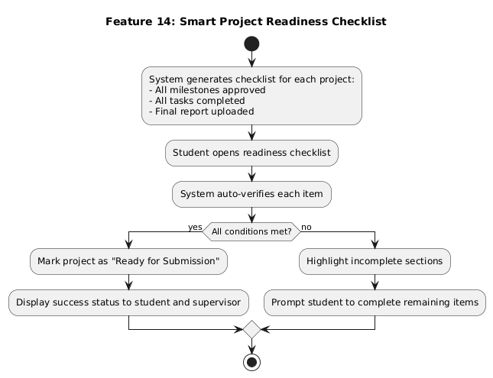

22.Archive Project

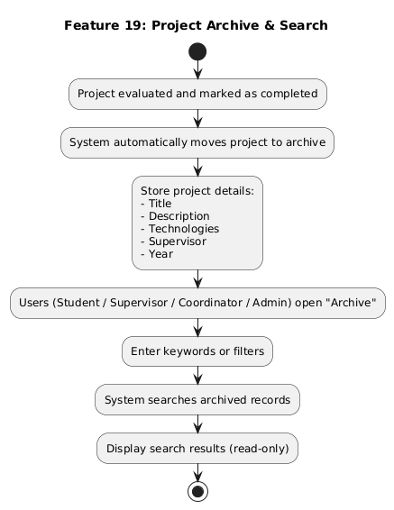

23.send/receive notification (noticeboard)
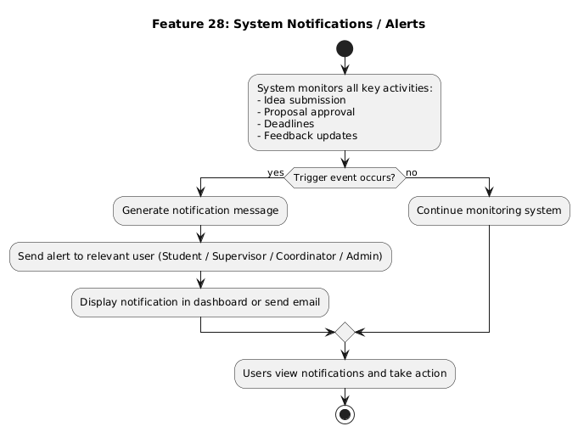

24 Upload Bulks
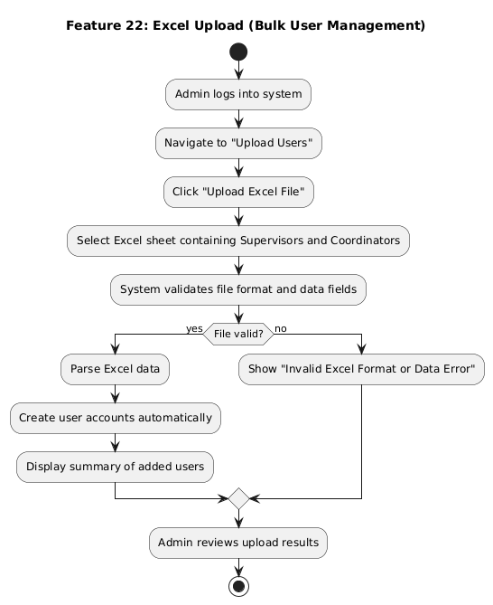

Appendix C:

Test Scenarios

Appendix C:

Test Scenarios

Test Case for UC-01: Register
System: Riphah Capstone  Designed By: Iman Arshad  Executed By: Iman Arshad  Short Description: Test registration process with valid, invalid, and duplicate data. | Designed Date: 3rd October 2025  Executed By: : 7th October 2025

Test Case ID | Test Case Description | Test Steps | Test Data | Expected Result | Actual Result | Pass/Fail
TC_1.1 | Verify successful registration with valid SAP ID and matching institutional email | 1. Open registration page.  2. Enter valid SAP ID, matching email, and strong password.  3. Click Create Account. | SAP ID: 46188Email: 46188@students.riphah.edu.pk  Password: Iman@123 | Account created successfully.Confirmation message “Registration successful.” displayed. | As expected | Pass
TC_1.2 | Verify registration fails if SAP ID and email do not match | 1. Enter SAP ID 46188 but use mismatched email 12345@students.riphah.edu.pk.  2. Click Create Account. | SAP ID: 46188Email: 12345@students.riphah.edu.pk  Password: Iman@123 | Error message “SAP ID and Email must match.” | As expected | Pass
TC_1.3 | Verify registration fails with invalid email format | 1. Enter email without “@students.riphah.edu.pk”. | SAP ID: 46188Email: 46188@gmail.com  Password: Iman@123 | Error “Invalid institutional email format.” | As expected | Pass
TC_1.4 | Verify password policy enforcement | 1. Enter weak password (no uppercase or special character).  2. Click Create Account. | SAP ID: 46188Email: 46188@students.riphah.edu.pk  Password: iman1234 | Error “Password must include uppercase and special character.” | As expected | Pass
TC_1.5 | Verify registration fails with missing fields | 1. Leave password or email empty.  2. Click Create Account. | SAP ID: 46188Email: (empty)  Password: Iman@123 | Error “All fields required.” | As expected | Pass
TC_1.6 | Verify duplicate email restriction | 1. Try registering again with an already registered email. | SAP ID: 46188Email: 46188@students.riphah.edu.pk | Error “Email already registered.” | As expected | Pass

Test Case for UC-02: Login

System: Riphah Capstone  Designed By: Sana Arshad  Executed By: Sana Arshad  Short Description: Validate login process for students, supervisors, coordinators, and admins, including first-time login password-update enforcement. | Designed Date: 3rd October 2025  Executed By: : 7th October 2025

Test Case ID | Test Case Description | Test Steps | Test Data | Expected Result | Actual Result | Pass/Fail
TC_2.1 | Verify successful student login with valid credentials | 1. Open login page.2. Enter registered student email and password.3. Click Login. | Email: 46188@students.riphah.edu.pk  Password: Iman@123 | Student redirected to dashboard. | As expected | Pass
TC_2.2 | Verify invalid credentials show error | 1. Enter wrong password.  2. Click Login. | Email: 46188@students.riphah.edu.pk  Password: Wrong@123 | Error message “Invalid credentials.” | As expected | Pass
TC_2.3 | Verify unapproved account cannot log in | 1. Attempt login before admin approval. | Email: newstudent@students.riphah.edu.pk  Password: Temp@123 | Message “Account not yet approved.” | As expected | Pass
TC_2.4 | Verify first-time login for supervisor/coordinator/admin shows password-update prompt | 1. Login using admin-provided temporary password.  2. Observe screen prompt. | Email: supervisor@riphah.edu.pk  Password: Temp@123 | Prompt to update password before accessing dashboard. | As expected | Pass
TC_2.5 | Verify institutional email format enforced | 1. Enter personal email (non-Riphah). | Email: iman@gmail.com  Password: Iman@123 | Error message “Invalid institutional email format.” | As expected | Pass

Test Case for UC-03: Update Password

Designed By: Ayesha Butt  Executed By: Ayesha Butt  Short Description: Ensure password-update prompt appears at first login for admin-created users and enforces password-strength policy. | Designed Date: 3rd October 2025  Executed By: : 7th October 2025

Test Case ID | Test Case Description | Test Steps | Test Data | Expected Result | Actual Result | Pass/Fail
TC_3.1 | Verify password-update prompt appears on first login | 1. Login with temporary credentials.  2. Observe system prompt for password update. | Username: supervisor@riphah.edu.pk  Password: Temp@123 | Password-update form displayed before dashboard access. | As expected | Pass
TC_3.2 | Verify password updated successfully with valid format | 1. Enter new password meeting policy rules.  2. Click Update Password. | Old: Temp@123  New: Ayesha@456 | Password updated successfully redirect to dashboard. | As expected | Pass
TC_3.3 | Verify mismatch between new and confirm password | 1. Enter mismatched new and confirm passwords.  2. Click Update Password. | New: Ayesha@456  Confirm: Ayesha@45 | Error “Passwords do not match.” | As expected | Pass
TC_3.4 | Verify weak password rejected | 1. Enter password without uppercase or special character.  2. Click Update Password. | New: ayesha123 | Error “Password must include an uppercase letter and special character.” | As expected | Pass
TC_3.5 | Verify minimum length requirement | 1. Enter password shorter than 8 characters.  2. Click Update Password. | New: Aye@1 | Error “Password must be at least 8 characters long.” | As expected | Pass

Test Case for UC-05: Role-Based Access Control
System: Riphah Capstone  Designed By: Sana Arshad  Executed By: Sana Arshad  Short Description: Validate access restriction for each system role. | Designed Date: 3rd October 2025  Executed By: : 7th October 2025

Test Case ID | Test Case Description | Test Steps | Test Data | Expected Result | Actual Result | Pass/Fail
TC_5.1 | Verify student cannot access admin features | Login as student and try accessing admin dashboard. | Role: Student | Access denied message. | As expected | Pass
TC_5.2 | Verify supervisor access limited to own groups | Login as supervisor; open other group data. | Role: Supervisor | Restricted access displayed. | As expected | Pass
TC_5.3 | Verify admin has full access | Login as admin; view all users. | Role: Admin | All records accessible. | As expected | Pass

Test Case for UC-06: Create Group

System: Riphah Capstone  Designed By: Ayesha Butt  Executed By: Ayesha Butt  Short Description: Ensure group creation and leader assignment works. | Designed Date: 3rd October 2025  Executed By: : 7th October 2025

Test Case ID | Test Case Description | Test Steps | Test Data | Expected Result | Actual Result | Pass/Fail
TC_6.1 | Verify group created successfully | Click 'Create Group.' Add members. | Member IDs: S001, S002 | Group created, leader assigned. | As expected | Pass
TC_6.2 | Verify group size limit | Add more than 3 members. | 4 members | Error 'Max 3 members allowed.' | As expected | Pass
TC_6.3 | Verify deletion allowed before proposal submission | Delete group before submitting proposal. | Group ID: G01 | Group deleted successfully. | As expected | Pass

Test Case for UC-07: Add Members
System: Riphah Capstone  Designed By: Iman Arshad  Executed By: Iman Arshad  Short Description: Validate adding members into a group by leader. | Designed Date: 3rd October 2025  Executed By: : 7th October 2025

Test Case ID | Test Case Description | Test Steps | Test Data | Expected Result | Actual Result | Pass/Fail
TC_7.1 | Verify successful member addition | Leader adds member by email/ID. | Member ID: S002 | Member added to group. | As expected | Pass
TC_7.2 | Verify duplicate member restriction | Try to add same member again. | Member ID: S002 | Message 'Member already added.' | As expected | Pass
TC_7.3 | Verify invalid member addition | Try adding non-existent student ID. | Member ID: S999 | Invalid member ID message. | As expected | Pass

Test Case for UC-10: Submit Project Idea

System: Riphah Capstone  Designed By: Iman Arshad  Executed By: Iman Arshad  Short Description: Test project idea submission and validation. | Designed Date: 3rd October 2025  Executed By: : 7th October 2025

Test Case ID | Test Case Description | Test Steps | Test Data | Expected Result | Actual Result | Pass/Fail
TC_10.1 | Verify idea submission success | Enter valid title, abstract, tools, domain. Click 'Submit.' | Title: Smart Attendance | Idea submitted successfully. | As expected | Pass
TC_10.2 | Verify empty field error | Leave abstract empty. | - | Message 'All fields required.' | As expected | Pass
TC_10.3 | Verify idea cannot be submitted before group creation | Try without group. | - | Error 'Create group first.' | As expected | Pass

Test Case for UC-11: Find Supervisor

System: Riphah Capstone  Designed By: Sana Arshad  Executed By: Sana Arshad  Short Description: Ensure students can find and select supervisors based on domain and availability. | Designed Date: 3rd October 2025  Executed By: : 7th October 2025

Test Case ID | Test Case Description | Test Steps | Test Data | Expected Result | Actual Result | Pass/Fail
TC_11.1 | Verify supervisor list displays correctly | Open 'Find Supervisor' page. | - | All supervisors listed with domain match and availability. | As expected | Pass
TC_11.2 | Verify selection of available supervisor | Click on 'Select Supervisor' for available supervisor. | Supervisor ID: SUP001 | Supervisor assigned successfully. | As expected | Pass
TC_11.3 | Verify full supervisor cannot be selected | Try selecting supervisor with full load. | Supervisor Load: 5/5 | Message 'Supervisor not available.' | As expected | Pass

Test Case for UC-12: AI Title Rewriter

System: Riphah Capstone  Designed By: Ayesha Butt  Executed By: Ayesha Butt  Short Description: Test AI-generated project title suggestions for accuracy and uniqueness. | Designed Date: 3rd October 2025  Executed By: : 7th October 2025

Test Case ID | Test Case Description | Test Steps | Test Data | Expected Result | Actual Result | Pass/Fail
TC_12.1 | Verify title suggestions generated | Enter rough project title. Click 'Rewrite with AI.' | Input: Attendance App | 4–5 academic title suggestions displayed. | As expected | Pass
TC_12.2 | Verify user can select AI suggestion | Select one suggested title. | Selected: Smart Attendance Management System | Title updated successfully. | As expected | Pass
TC_12.3 | Verify error when no title entered | Click 'Rewrite with AI' with empty field. | - | Message 'Please enter a title.' | As expected | Pass

Test Case for UC-17: Approve / Reject Proposal
System: Riphah Capstone  Designed By: Sana Arshad  Executed By: Sana Arshad  Short Description: Ensure supervisor can approve or reject student proposal. | Designed Date: 3rd October 2025  Executed By: : 7th October 2025

Test Case ID | Test Case Description | Test Steps | Test Data | Expected Result | Actual Result | Pass/Fail
TC_17.1 | Verify supervisor approves proposal | Click 'Approve' button on proposal page. | Proposal ID: P001 | Proposal marked as approved. | As expected | Pass
TC_17.2 | Verify supervisor rejects proposal | Click 'Reject' and add comments. | Reason: Incomplete content | Proposal marked rejected. | As expected | Pass
TC_17.3 | Verify student notified of decision | Check student dashboard. | - | Status updated notification shown. | As expected | Pass

Test Case for UC-19: Post Whiteboard Note
System: Riphah Capstone  Designed By: Iman Arshad  Executed By: Iman Arshad  Short Description: Ensure supervisors can post and update notes on whiteboard. | Designed Date: 3rd October 2025  Executed By: : 7th October 2025

Test Case ID | Test Case Description | Test Steps | Test Data | Expected Result | Actual Result | Pass/Fail
TC_19.1 | Verify note posted successfully | Supervisor types and posts note. | Note: Submit report draft. | Note displayed on student dashboard. | As expected | Pass
TC_19.2 | Verify formatting options | Apply bold and color formatting. | - | Formatted text appears correctly. | As expected | Pass
TC_19.3 | Verify note update | Edit previously posted note. | - | Note updated successfully. | As expected | Pass

Test Case for UC-20: View Whiteboard Note
System: Riphah Capstone  Designed By: Sana Arshad  Executed By: Sana Arshad  Short Description: Validate that students can view supervisor’s whiteboard notes. | Designed Date: 3rd October 2025  Executed By: : 7th October 2025

Test Case ID | Test Case Description | Test Steps | Test Data | Expected Result | Actual Result | Pass/Fail
TC_20.1 | Verify note visibility | Student views dashboard. | - | All supervisor notes visible. | As expected | Pass
TC_20.2 | Verify autorefresh of new notes | Supervisor adds new note. | - | New note appears automatically. | As expected | Pass
TC_20.3 | Verify restricted access | Nongroup students try to view. | - | Access denied message shown. | As expected | Pass

Test Case for UC-21: Evaluate Milestone
System: Riphah Capstone  Designed By: Ayesha Butt  Executed By: Ayesha Butt  Short Description: Ensure supervisors can evaluate milestones using rubric-based system. | Designed Date: 3rd October 2025  Executed By: : 7th October 2025

Test Case ID | Test Case Description | Test Steps | Test Data | Expected Result | Actual Result | Pass/Fail
TC_21.1 | Verify supervisor can enter marks | Open evaluation page and input rubric scores. | - | Scores saved successfully. | As expected | Pass
TC_21.2 | Verify automatic total calculation | Enter different rubric scores. | - | Total score auto-calculated correctly. | As expected | Pass
TC_21.3 | Verify feedback submission | Enter marks and feedback. | - | Feedback saved with evaluation. | As expected | Pass

Test Case for UC-22: Committee Evaluate
System: Riphah Capstone  Designed By: Iman Arshad  Executed By: Iman Arshad  Short Description: Test evaluation functionality for committee members. | Designed Date: 3rd October 2025  Executed By: : 7th October 2025

Test Case ID | Test Case Description | Test Steps | Test Data | Expected Result | Actual Result | Pass/Fail
TC_22.1 | Verify committee can access project | Login as committee member; open project. | - | Project accessible for evaluation. | As expected | Pass
TC_22.2 | Verify evaluation submission | Enter evaluation remarks and save. | - | Evaluation recorded successfully. | As expected | Pass
TC_22.3 | Verify restricted access after submission | Try editing after submission. | - | Editing disabled post submission. | As expected | Pass

Test Case for UC-23: Supervisor Evaluate
System: Riphah Capstone  Designed By: Sana Arshad  Executed By: Sana Arshad  Short Description: Ensure supervisor can evaluate group milestones accurately. | Designed Date: 3rd October 2025  Executed By: : 7th October 2025

Test Case ID | Test Case Description | Test Steps | Test Data | Expected Result | Actual Result | Pass/Fail
TC_23.1 | Verify milestone grading by supervisor | Open milestone evaluation panel and grade. | - | Grades saved successfully. | As expected | Pass
TC_23.2 | Verify feedback visible to students | Add feedback and submit. | - | Feedback shown in student dashboard. | As expected | Pass
TC_23.3 | Verify evaluation history stored | Reopen project to view history. | - | Past evaluations displayed. | As expected | Pass

Test Case for UC-24: Manage Supervisor Supervising Slots

System: Riphah Capstone  Designed By: Ayesha Butt  Executed By: Ayesha Butt  Short Description: Ensure coordinators can manage supervisor slots. | Designed Date: 3rd October 2025  Executed By: : 7th October 2025

Test Case ID | Test Case Description | Test Steps | Test Data | Expected Result | Actual Result | Pass/Fail
TC_24.1 | Verify coordinator sets slot limit | Set slot limit for a supervisor. | Slots: 5 | Limit saved successfully. | As expected | Pass
TC_24.2 | Verify supervisor availability updates | Assign groups until limit reached. | - | Supervisor shown as 'Full'. | As expected | Pass
TC_24.3 | Verify admin override capability | Admin changes slot limit. | New limit: 7 | Slot updated successfully. | As expected | Pass

Test Case for UC-27: Post Comments
System: Riphah Capstone  Designed By: Ayesha Butt  Executed By: Ayesha Butt  Short Description: Ensure users can post and view comments on milestones or reports. | Designed Date: 3rd October 2025  Executed By: : 7th October 2025

Test Case ID | Test Case Description | Test Steps | Test Data | Expected Result | Actual Result | Pass/Fail
TC_27.1 | Verify comment posted successfully | Add comment to milestone. | Comment: Good work | Comment displayed immediately. | As expected | Pass
TC_27.2 | Verify comment visibility to group | Other members view comment. | - | Visible to all group members. | As expected | Pass
TC_27.3 | Verify delete comment permission | Try deleting another user’s comment. | - | Access denied message shown. | As expected | Pass

Test Case for UC-28: Configure & Upload Supervisors
System: Riphah Capstone  Designed By: Iman Arshad  Executed By: Iman Arshad  Short Description: Ensure the Admin can configure supervisor details manually or through bulk upload (.xlsx). | Designed Date: 3rd October 2025  Executed By: : 7th October 2025

Test Case ID | Test Case Description | Test Steps | Test Data | Expected Result | Actual Result | Pass/Fail
TC_28.1 | Verify manual supervisor configuration | Go to Admin → Supervisor Management → Add Supervisor. Enter domain, email, and name. Click “Save.” | Domain: AI & MLEmail: supervisor@riphah.edu.pk | Supervisor details saved successfully. | As expected | Pass
TC_28.2 | Verify supervisor update | Select existing supervisor → Edit details → Save. | Domain: Updated to “Data Science” | Supervisor details updated successfully. | As expected | Pass
TC_28.3 | Verify domain validation | Enter invalid domain format and save. | Domain: 123@@invalid | Error message “Invalid domain format.” | As expected | Pass
TC_28.4 | Verify Excel file upload for bulk supervisors | Go to Admin → Upload Supervisors → Select valid Excel file. | File: Supervisors.xlsx | Supervisors added in bulk successfully. | As expected | Pass
TC_28.5 | Verify invalid Excel file upload | Upload invalid or non-Excel file. | File: Supervisors.txt | Error message “Invalid file format.” | As expected | Pass
TC_28.6 | Verify duplicate handling in Excel upload | Upload Excel file with existing supervisors. | File: Supervisors.xlsx (duplicates) | Duplicate entries skipped with warning. | As expected | Pass

Reference and Bibliography

[1] M. Sher, M. Rehman, “Title of the Paper” Conference name/Journal Name, Edition, Volume, Issue, ISBN/ISSN, PP, Publisher/City-Country, Year.
[2] ……

Appendix A:
Heading (20-Point Size, Times New Roman, Bold)

Text in 12-Point Size, Times New Roman, 1.5 Line Spacing.

  - First Level heading [14-Point Size, Times New Roman, Bold and left aligned

Text in 12-Point Size, Times New Roman, 1.5 Line Spacing.

1.1.1 Second level heading [12-Point Size, Times New Roman, Bold and left aligned]

Text in 12-Point Size, Times New Roman, 1.5 Line Spacing.

